Browsing_richness_modelling

Chayanit Jaroonsophonsak

2022-08-30

# Import data

rich_df = read.csv("./data_generated/richness_calculation.csv")  
head(rich_df)

## X Time Plot_number Treatment Quadrat_number Quadrat_fenced Quadrat_gap  
## 1 1 0-3 7 Radial 1 False False  
## 2 2 0-3 7 Radial 2 True True  
## 3 3 0-3 7 Radial 3 False True  
## 4 4 0-3 7 Radial 4 True True  
## 5 5 0-3 7 Radial 5 False False  
## 6 6 0-3 7 Radial 6 True False  
## Richness_change  
## 1 0  
## 2 -5  
## 3 4  
## 4 4  
## 5 -1  
## 6 0

# H: Removal of browsing will cause a greater increase in understorey species richness in T1 compared to T2

## Visualisation

#Year 0 to 3  
rich_fenced_03=rich_df[rich_df$Time=="0-3" & rich_df$Quadrat_fenced=="True",]  
plot(rich_fenced_03$Richness_change, xlab="16 fenced quadrats for each plot: 7, 9, 10, 12", ylab="change in species richness", main="Change in species richness from Y0 to Y3 after browsing exclusion", col=factor(rich_fenced_03$Treatment))  
abline(h=0, lty=2)  
legend("bottomright", legend = paste(c("T1","T2")), col=c("black","red"), pch=1)

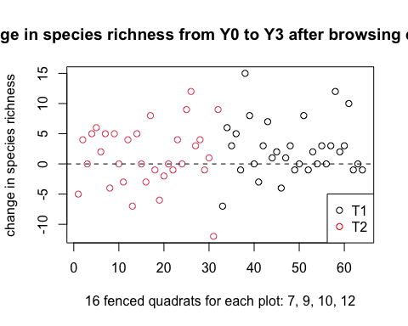

boxplot(rich_fenced_03$Richness_change~rich_fenced_03$Treatment, xlab="Treatment", ylab="Change in species richness", main="Change in species richness from Y0 to Y3 after browsing exclusion")

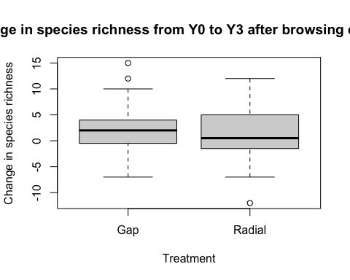

hist(rich_fenced_03$Richness_change)

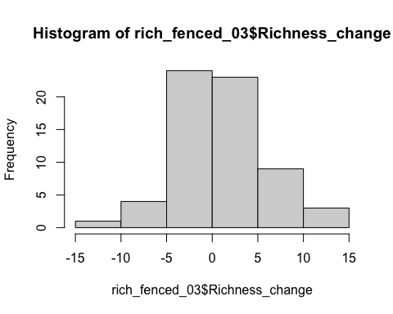

#Year 3 to 6  
rich_fenced_36=rich_df[rich_df$Time=="3-6" & rich_df$Quadrat_fenced=="True",]  
plot(rich_fenced_36$Richness_change, xlab="16 fenced quadrats for each plot: 7, 9, 10, 12", ylab="change in species richness", main="Change in species richness from Y3 to Y6 after browsing exclusion", col=factor(rich_fenced_36$Treatment))  
abline(h=0, lty=2)  
legend("bottomright", legend = paste(c("T1","T2")), col=c("black","red"), pch=1)

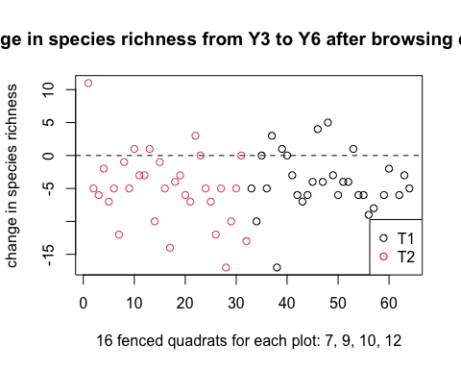

boxplot(rich_fenced_36$Richness_change~rich_fenced_36$Treatment, xlab="Treatment", ylab="Change in species richness", main="Change in species richness from Y3 to Y6 after browsing exclusion")

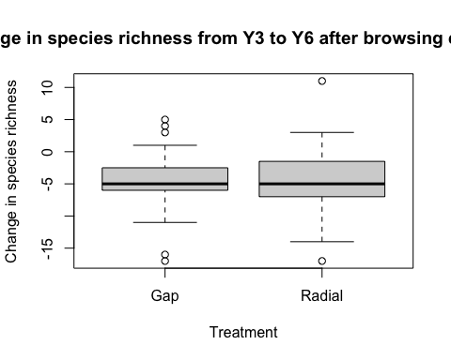

hist(rich_fenced_36$Richness_change)

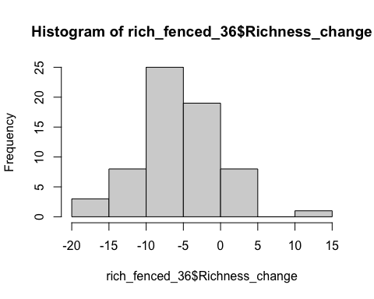

#Year 0 to 6  
rich_fenced_06=rich_df[rich_df$Time=="0-6" & rich_df$Quadrat_fenced=="True",]  
plot(rich_fenced_06$Richness_change, xlab="16 fenced quadrats for each plot: 7, 9, 10, 12", ylab="change in species richness", main="Change in species richness from Y0 to Y6 after browsing exclusion", col=factor(rich_fenced_06$Treatment))  
abline(h=0, lty=2)  
legend("bottomright", legend = paste(c("T1","T2")), col=c("black","red"), pch=1)

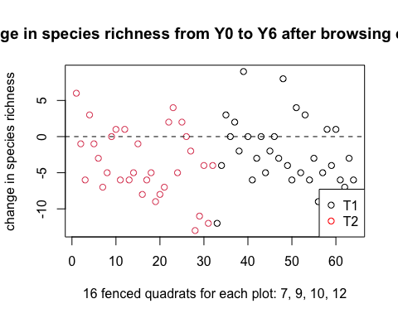

boxplot(rich_fenced_06$Richness_change~rich_fenced_06$Treatment, xlab="Treatment", ylab="Change in species richness", main="Change in species richness from Y0 to Y6 after browsing exclusion")

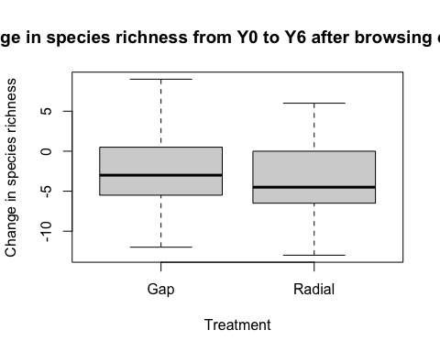

hist(rich_fenced_06$Richness_change)

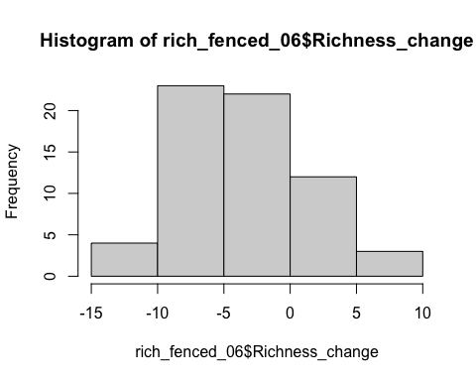

## Modelling

### Year 0 to 3 (Choose Negative Binomial GLM)

#Linear model  
rich_03_lm_a=lm(Richness_change~Treatment+Quadrat_gap, rich_fenced_03)  
summary(rich_03_lm_a)

##   
## Call:  
## lm(formula = Richness_change ~ Treatment + Quadrat_gap, data = rich_fenced_03)  
##   
## Residuals:  
## Min 1Q Median 3Q Max   
## -13.5532 -2.8259 -0.4316 3.4468 12.1741   
##   
## Coefficients:  
## Estimate Std. Error t value Pr(>|t|)  
## (Intercept) 1.583 1.295 1.222 0.226  
## TreatmentRadial -1.273 1.235 -1.031 0.307  
## Quadrat_gapTrue 1.243 1.398 0.889 0.377  
##   
## Residual standard error: 4.911 on 61 degrees of freedom  
## Multiple R-squared: 0.02677, Adjusted R-squared: -0.005143   
## F-statistic: 0.8388 on 2 and 61 DF, p-value: 0.4371

plot(rich_03_lm_a)

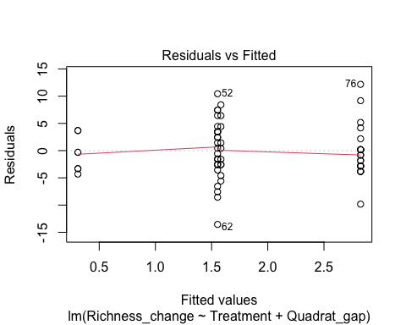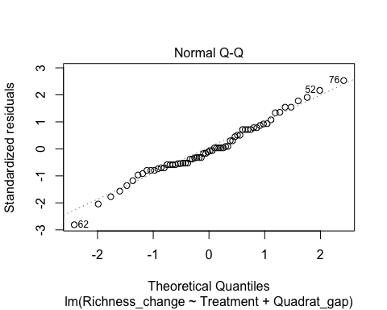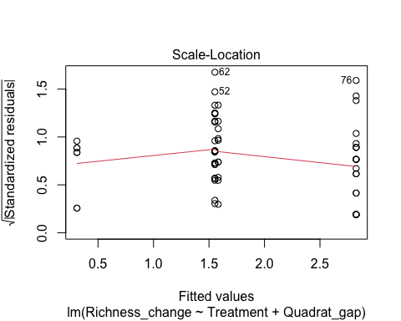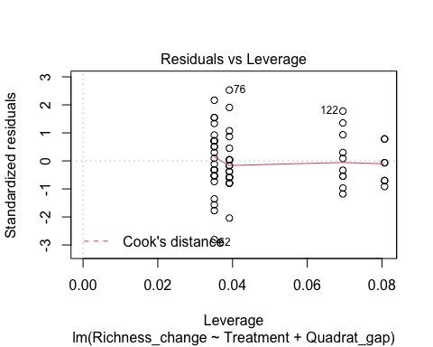

rich_03_lm_b=lm(Richness_change~Quadrat_gap, rich_fenced_03)  
anova(rich_03_lm_b,rich_03_lm_a)

## Analysis of Variance Table  
##   
## Model 1: Richness_change ~ Quadrat_gap  
## Model 2: Richness_change ~ Treatment + Quadrat_gap  
## Res.Df RSS Df Sum of Sq F Pr(>F)  
## 1 62 1496.9   
## 2 61 1471.3 1 25.628 1.0625 0.3067

#Treatment is not significant

#Poisson GLM  
#manipulate data by adding a constant to every y, so that they are all non-negative  
a=min(rich_fenced_03$Richness_change)  
rich_fenced_03$Richness_change_pos=rich_fenced_03$Richness_change + abs(a)  
  
#visualisation and test if the data is poisson  
hist(rich_fenced_03$Richness_change_pos)  
library(fitdistrplus)

## Loading required package: MASS

## Loading required package: survival

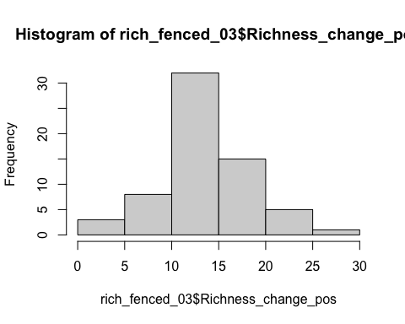

poisson.model1=fitdist(rich_fenced_03$Richness_change_pos,"pois",method=c("mle"))  
poisson.model1

## Fitting of the distribution ' pois ' by maximum likelihood   
## Parameters:  
## estimate Std. Error  
## lambda 13.85938 0.4653523

poisson.lambda=13.85938  
  
plot(poisson.model1)

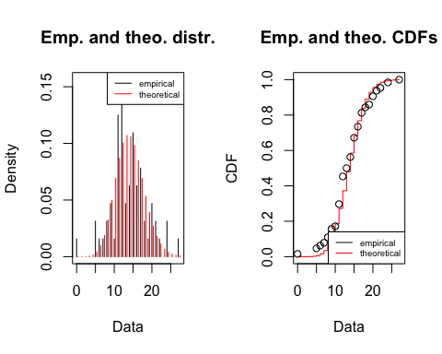

n=length(rich_fenced_03$Richness_change_pos)  
samp.pct <- (1:n-0.5)/n  
qqplot(x=qpois(samp.pct,poisson.lambda), y=sort(rich_fenced_03$Richness_change_pos), xlab = 'Theoretical quantiles', ylab = 'Empirical quantiles', main='Q-Q plot Poisson')  
abline(0,1,col="red")

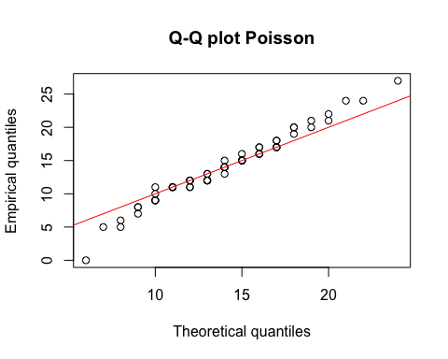

#fit the model  
library(boot)

##   
## Attaching package: 'boot'

## The following object is masked from 'package:survival':  
##   
## aml

rich_03_pois_a=glm(Richness_change_pos~Treatment+Quadrat_gap, rich_fenced_03, family = poisson)  
summary(rich_03_pois_a)

##   
## Call:  
## glm(formula = Richness_change_pos ~ Treatment + Quadrat_gap,   
## family = poisson, data = rich_fenced_03)  
##   
## Deviance Residuals:   
## Min 1Q Median 3Q Max   
## -5.2037 -0.7633 -0.1252 0.9042 2.8279   
##   
## Coefficients:  
## Estimate Std. Error z value Pr(>|z|)   
## (Intercept) 2.60626 0.07210 36.149 <2e-16 ***  
## TreatmentRadial -0.09184 0.06757 -1.359 0.174   
## Quadrat_gapTrue 0.09117 0.07793 1.170 0.242   
## ---  
## Signif. codes: 0 '***' 0.001 '**' 0.01 '*' 0.05 '.' 0.1 ' ' 1  
##   
## (Dispersion parameter for poisson family taken to be 1)  
##   
## Null deviance: 121.97 on 63 degrees of freedom  
## Residual deviance: 119.04 on 61 degrees of freedom  
## AIC: 404.72  
##   
## Number of Fisher Scoring iterations: 4

glm.diag.plots((rich_03_pois_a))

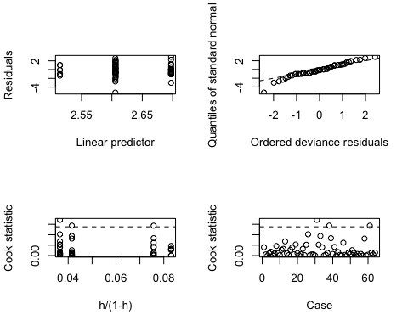

rich_03_pois_b=glm(Richness_change_pos~Treatment, rich_fenced_03, family = poisson)  
summary(rich_03_pois_b)

##   
## Call:  
## glm(formula = Richness_change_pos ~ Treatment, family = poisson,   
## data = rich_fenced_03)  
##   
## Deviance Residuals:   
## Min 1Q Median 3Q Max   
## -5.1539 -0.7312 -0.1157 0.7675 2.9461   
##   
## Coefficients:  
## Estimate Std. Error z value Pr(>|z|)   
## (Intercept) 2.66983 0.04652 57.386 <2e-16 ***  
## TreatmentRadial -0.08348 0.06721 -1.242 0.214   
## ---  
## Signif. codes: 0 '***' 0.001 '**' 0.01 '*' 0.05 '.' 0.1 ' ' 1  
##   
## (Dispersion parameter for poisson family taken to be 1)  
##   
## Null deviance: 121.97 on 63 degrees of freedom  
## Residual deviance: 120.43 on 62 degrees of freedom  
## AIC: 404.11  
##   
## Number of Fisher Scoring iterations: 4

#goodness of fit  
qchisq(0.95,61)

## [1] 80.2321

#not adequate  
library(msme)

## Loading required package: lattice

##   
## Attaching package: 'lattice'

## The following object is masked from 'package:boot':  
##   
## melanoma

P__disp(rich_03_pois_b)

## pearson.chi2 dispersion   
## 108.210919 1.745337

#dispersion is high (>1)

#Negative Binomial GLM  
#Test if the data is Negative Binomial   
nbinom.model1=fitdist(rich_fenced_03$Richness_change_pos,"nbinom",method=c("mle"))  
nbinom.model1

## Fitting of the distribution ' nbinom ' by maximum likelihood   
## Parameters:  
## estimate Std. Error  
## size 17.38644 7.3759923  
## mu 13.85894 0.6238103

size.nbinom=17.38644 #first parameter   
mu.nbinom=13.85894  
prob.nbinom=size.nbinom/(size.nbinom+mu.nbinom)   
prob.nbinom

## [1] 0.5564483

plot(nbinom.model1)

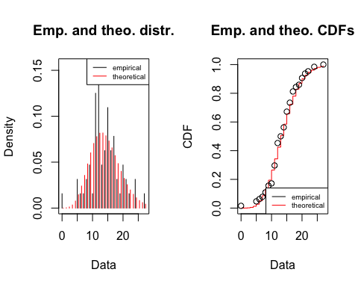

qqplot(x=qnbinom(samp.pct,size.nbinom,prob.nbinom), y=sort(rich_fenced_03$Richness_change_pos), xlab = 'Theoretical quantiles', ylab = 'Empirical quantiles', main='Q-Q plot Negative Binomial')  
abline(0,1,col="red")

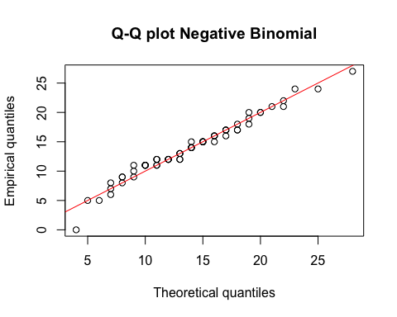

#looks better than Poisson  
  
#fit the model  
rich_03_nb_a=glm.nb(Richness_change_pos~Treatment+Quadrat_gap, rich_fenced_03)  
summary(rich_03_nb_a)

##   
## Call:  
## glm.nb(formula = Richness_change_pos ~ Treatment + Quadrat_gap,   
## data = rich_fenced_03, init.theta = 18.60057888, link = log)  
##   
## Deviance Residuals:   
## Min 1Q Median 3Q Max   
## -4.5103 -0.5799 -0.0942 0.6770 2.0055   
##   
## Coefficients:  
## Estimate Std. Error z value Pr(>|z|)   
## (Intercept) 2.60585 0.09455 27.560 <2e-16 ***  
## TreatmentRadial -0.09275 0.08927 -1.039 0.299   
## Quadrat_gapTrue 0.09233 0.10217 0.904 0.366   
## ---  
## Signif. codes: 0 '***' 0.001 '**' 0.01 '*' 0.05 '.' 0.1 ' ' 1  
##   
## (Dispersion parameter for Negative Binomial(18.6006) family taken to be 1)  
##   
## Null deviance: 75.028 on 63 degrees of freedom  
## Residual deviance: 73.325 on 61 degrees of freedom  
## AIC: 396.14  
##   
## Number of Fisher Scoring iterations: 1  
##   
##   
## Theta: 18.60   
## Std. Err.: 8.21   
##   
## 2 x log-likelihood: -388.137

rich_03_nb_b=glm.nb(Richness_change_pos~Treatment, rich_fenced_03)  
summary(rich_03_nb_b) # choose this model

##   
## Call:  
## glm.nb(formula = Richness_change_pos ~ Treatment, data = rich_fenced_03,   
## init.theta = 18.01098589, link = log)  
##   
## Deviance Residuals:   
## Min 1Q Median 3Q Max   
## -4.4607 -0.5536 -0.0864 0.5708 2.0843   
##   
## Coefficients:  
## Estimate Std. Error z value Pr(>|z|)   
## (Intercept) 2.66983 0.06245 42.754 <2e-16 ***  
## TreatmentRadial -0.08348 0.08937 -0.934 0.35   
## ---  
## Signif. codes: 0 '***' 0.001 '**' 0.01 '*' 0.05 '.' 0.1 ' ' 1  
##   
## (Dispersion parameter for Negative Binomial(18.011) family taken to be 1)  
##   
## Null deviance: 74.138 on 63 degrees of freedom  
## Residual deviance: 73.266 on 62 degrees of freedom  
## AIC: 394.95  
##   
## Number of Fisher Scoring iterations: 1  
##   
##   
## Theta: 18.01   
## Std. Err.: 7.80   
##   
## 2 x log-likelihood: -388.949

#goodness of fit  
qchisq(0.95,61)

## [1] 80.2321

#adequate  
#Treatment is not significant

# try incorporate random effects

library(lme4)

## Loading required package: Matrix

rich_03_nbmm_b=glmer.nb(Richness_change_pos~Treatment+(1|Plot_number/Quadrat_number), data=rich_fenced_03)

## Warning in theta.ml(Y, mu, weights = object@resp$weights, limit = limit, :  
## iteration limit reached

## boundary (singular) fit: see ?isSingular

summary(rich_03_nbmm_b)

## Generalized linear mixed model fit by maximum likelihood (Laplace  
## Approximation) [glmerMod]  
## Family: Negative Binomial(2309.82) ( log )  
## Formula: Richness_change_pos ~ Treatment + (1 | Plot_number/Quadrat_number)  
## Data: rich_fenced_03  
##   
## AIC BIC logLik deviance df.resid   
## 399.5 410.3 -194.8 389.5 59   
##   
## Scaled residuals:   
## Min 1Q Median 3Q Max   
## -2.89716 -0.38325 -0.01566 0.50146 1.54705   
##   
## Random effects:  
## Groups Name Variance Std.Dev.   
## Quadrat_number:Plot_number (Intercept) 5.100e-02 2.258e-01  
## Plot_number (Intercept) 1.686e-12 1.298e-06  
## Number of obs: 64, groups: Quadrat_number:Plot_number, 64; Plot_number, 4  
##   
## Fixed effects:  
## Estimate Std. Error z value Pr(>|z|)   
## (Intercept) 2.64624 0.06221 42.538 <2e-16 ***  
## TreatmentRadial -0.08711 0.08834 -0.986 0.324   
## ---  
## Signif. codes: 0 '***' 0.001 '**' 0.01 '*' 0.05 '.' 0.1 ' ' 1  
##   
## Correlation of Fixed Effects:  
## (Intr)  
## TreatmntRdl -0.688  
## optimizer (Nelder_Mead) convergence code: 0 (OK)  
## boundary (singular) fit: see ?isSingular

#test the significance of random effect  
LRT = 2 * (-logLik(rich_03_nbmm_b)) - 2 * (-logLik(rich_03_nb_b))   
LRT

## 'log Lik.' 0.5635556 (df=5)

pchisq(as.numeric(LRT), df=2, lower.tail=F)

## [1] 0.7544413

#not significant

#Year 3 to 6 (Choose Negative Binomial GLM*)

#Linear model  
rich_36_lm_a=lm(Richness_change~Treatment+Quadrat_gap, rich_fenced_36)  
summary(rich_36_lm_a)

##   
## Call:  
## lm(formula = Richness_change ~ Treatment + Quadrat_gap, data = rich_fenced_36)  
##   
## Residuals:  
## Min 1Q Median 3Q Max   
## -12.4663 -1.9927 0.2535 2.3566 16.2535   
##   
## Coefficients:  
## Estimate Std. Error t value Pr(>|t|)   
## (Intercept) -3.5337 1.3778 -2.565 0.0128 *  
## TreatmentRadial -0.1324 1.3136 -0.101 0.9200   
## Quadrat_gapTrue -1.5873 1.4871 -1.067 0.2900   
## ---  
## Signif. codes: 0 '***' 0.001 '**' 0.01 '*' 0.05 '.' 0.1 ' ' 1  
##   
## Residual standard error: 5.225 on 61 degrees of freedom  
## Multiple R-squared: 0.01907, Adjusted R-squared: -0.01309   
## F-statistic: 0.5929 on 2 and 61 DF, p-value: 0.5559

plot(rich_36_lm_a)

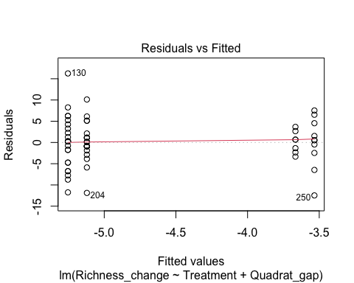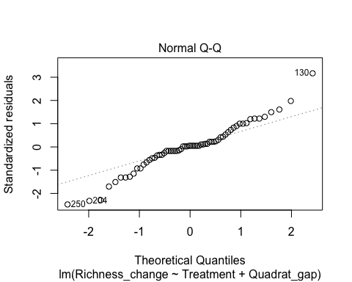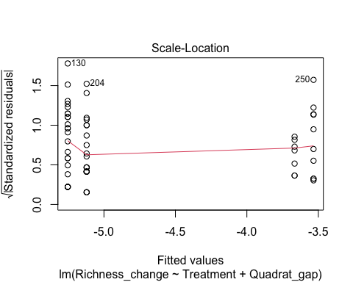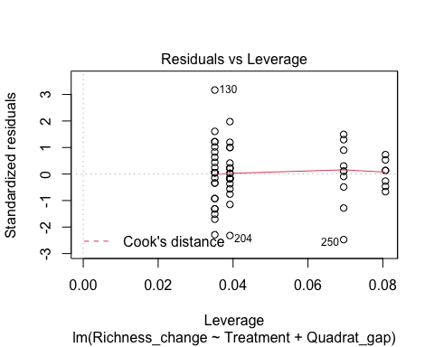

rich_36_lm_b=lm(Richness_change~Quadrat_gap, rich_fenced_36)  
anova(rich_36_lm_b,rich_36_lm_a)

## Analysis of Variance Table  
##   
## Model 1: Richness_change ~ Quadrat_gap  
## Model 2: Richness_change ~ Treatment + Quadrat_gap  
## Res.Df RSS Df Sum of Sq F Pr(>F)  
## 1 62 1665.4   
## 2 61 1665.1 1 0.27747 0.0102 0.92

#Treatment is not significant

#Poisson GLM  
#manipulate data by adding a constant to every y, so that they are all non-negative  
b=min(rich_fenced_36$Richness_change)  
rich_fenced_36$Richness_change_pos=rich_fenced_36$Richness_change + abs(b)  
  
#visualisation and test if the data is poisson  
hist(rich_fenced_36$Richness_change_pos)

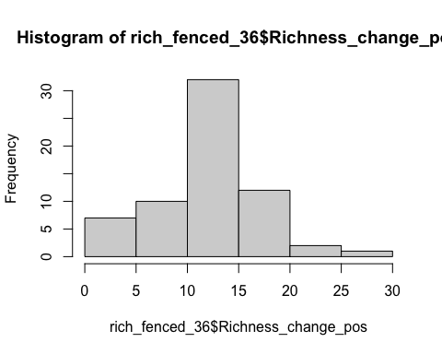

poisson.model2=fitdist(rich_fenced_36$Richness_change_pos,"pois",method=c("mle"))  
poisson.model2

## Fitting of the distribution ' pois ' by maximum likelihood   
## Parameters:  
## estimate Std. Error  
## lambda 12.23438 0.4372209

poisson.lambda2=12.23438   
  
plot(poisson.model2)

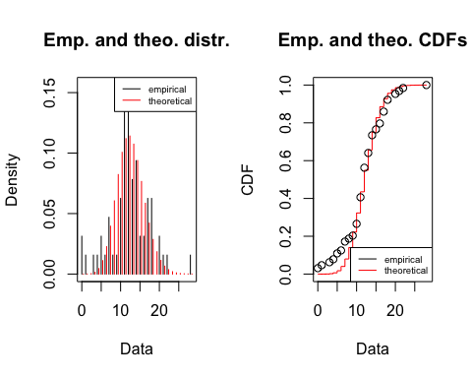

n2=length(rich_fenced_36$Richness_change_pos)  
samp.pct2 <- (1:n2-0.5)/n2  
qqplot(x=qpois(samp.pct2,poisson.lambda2), y=sort(rich_fenced_36$Richness_change_pos), xlab = 'Theoretical quantiles', ylab = 'Empirical quantiles', main='Q-Q plot Poisson')  
abline(0,1,col="red")

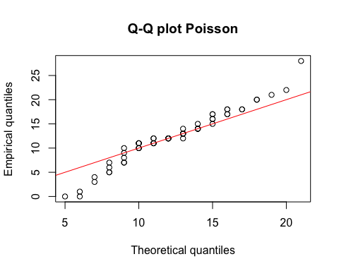

#data has heavier tails than Poisson  
  
#fit the model  
rich_36_pois_a=glm(Richness_change_pos~Treatment+Quadrat_gap, rich_fenced_36, family = poisson)  
summary(rich_36_pois_a)

##   
## Call:  
## glm(formula = Richness_change_pos ~ Treatment + Quadrat_gap,   
## family = poisson, data = rich_fenced_36)  
##   
## Deviance Residuals:   
## Min 1Q Median 3Q Max   
## -4.8737 -0.5843 0.0731 0.6555 4.0164   
##   
## Coefficients:  
## Estimate Std. Error z value Pr(>|z|)   
## (Intercept) 2.60058 0.07247 35.886 <2e-16 ***  
## TreatmentRadial -0.01083 0.07191 -0.151 0.880   
## Quadrat_gapTrue -0.12601 0.07913 -1.592 0.111   
## ---  
## Signif. codes: 0 '***' 0.001 '**' 0.01 '*' 0.05 '.' 0.1 ' ' 1  
##   
## (Dispersion parameter for poisson family taken to be 1)  
##   
## Null deviance: 168.04 on 63 degrees of freedom  
## Residual deviance: 165.44 on 61 degrees of freedom  
## AIC: 437.71  
##   
## Number of Fisher Scoring iterations: 4

rich_36_pois_b=glm(Richness_change_pos~Treatment, rich_fenced_36, family = poisson)  
summary(rich_36_pois_b)

##   
## Call:  
## glm(formula = Richness_change_pos ~ Treatment, family = poisson,   
## data = rich_fenced_36)  
##   
## Deviance Residuals:   
## Min 1Q Median 3Q Max   
## -4.9749 -0.6208 -0.0270 0.7427 3.8988   
##   
## Coefficients:  
## Estimate Std. Error z value Pr(>|z|)   
## (Intercept) 2.51568 0.05025 50.062 <2e-16 ***  
## TreatmentRadial -0.02299 0.07148 -0.322 0.748   
## ---  
## Signif. codes: 0 '***' 0.001 '**' 0.01 '*' 0.05 '.' 0.1 ' ' 1  
##   
## (Dispersion parameter for poisson family taken to be 1)  
##   
## Null deviance: 168.04 on 63 degrees of freedom  
## Residual deviance: 167.93 on 62 degrees of freedom  
## AIC: 438.2  
##   
## Number of Fisher Scoring iterations: 4

#goodness of fit  
qchisq(0.95,61)

## [1] 80.2321

#not adequate  
P__disp(rich_36_pois_b)

## pearson.chi2 dispersion   
## 138.847310 2.239473

#very high dispersion (>1)

#Negative Binomial GLM  
#Test if the data is Negative Binomial   
nbinom.model2=fitdist(rich_fenced_36$Richness_change_pos,"nbinom",method=c("mle"))  
nbinom.model2

## Fitting of the distribution ' nbinom ' by maximum likelihood   
## Parameters:  
## estimate Std. Error  
## size 7.670044 2.4889213  
## mu 12.233783 0.7042759

size.nbinom2=7.670044 #first parameter   
mu.nbinom2=12.233783   
prob.nbinom2=size.nbinom2/(size.nbinom2+mu.nbinom2)   
prob.nbinom2

## [1] 0.3853552

plot(nbinom.model2)

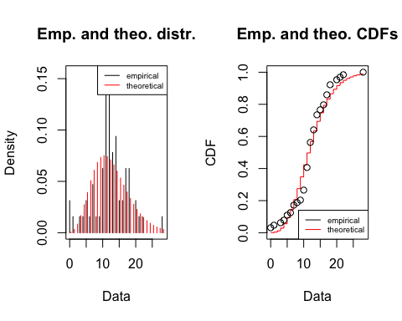

qqplot(x=qnbinom(samp.pct2,size.nbinom2,prob.nbinom2), y=sort(rich_fenced_36$Richness_change_pos), xlab = 'Theoretical quantiles', ylab = 'Empirical quantiles', main='Q-Q plot Negative Binomial')  
abline(0,1,col="red")

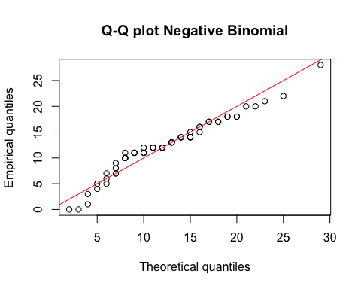

#better than Poisson, but is it good enough (?)  
  
#fit the model  
rich_36_nb_a=glm.nb(Richness_change_pos~Treatment+Quadrat_gap, rich_fenced_36)  
summary(rich_36_nb_a)

##   
## Call:  
## glm.nb(formula = Richness_change_pos ~ Treatment + Quadrat_gap,   
## data = rich_fenced_36, init.theta = 7.923265233, link = log)  
##   
## Deviance Residuals:   
## Min 1Q Median 3Q Max   
## -3.8098 -0.3726 0.0466 0.4046 2.3174   
##   
## Coefficients:  
## Estimate Std. Error z value Pr(>|z|)   
## (Intercept) 2.60071 0.11845 21.956 <2e-16 ***  
## TreatmentRadial -0.01111 0.11471 -0.097 0.923   
## Quadrat_gapTrue -0.12601 0.12840 -0.981 0.326   
## ---  
## Signif. codes: 0 '***' 0.001 '**' 0.01 '*' 0.05 '.' 0.1 ' ' 1  
##   
## (Dispersion parameter for Negative Binomial(7.9233) family taken to be 1)  
##   
## Null deviance: 79.755 on 63 degrees of freedom  
## Residual deviance: 78.746 on 61 degrees of freedom  
## AIC: 411.13  
##   
## Number of Fisher Scoring iterations: 1  
##   
##   
## Theta: 7.92   
## Std. Err.: 2.61   
##   
## 2 x log-likelihood: -403.132

rich_36_nb_b=glm.nb(Richness_change_pos~Treatment, rich_fenced_36)  
summary(rich_36_nb_b) #choose this model*

##   
## Call:  
## glm.nb(formula = Richness_change_pos ~ Treatment, data = rich_fenced_36,   
## init.theta = 7.677246836, link = log)  
##   
## Deviance Residuals:   
## Min 1Q Median 3Q Max   
## -3.8395 -0.3942 -0.0168 0.4509 2.2119   
##   
## Coefficients:  
## Estimate Std. Error z value Pr(>|z|)   
## (Intercept) 2.51568 0.08121 30.98 <2e-16 ***  
## TreatmentRadial -0.02299 0.11511 -0.20 0.842   
## ---  
## Signif. codes: 0 '***' 0.001 '**' 0.01 '*' 0.05 '.' 0.1 ' ' 1  
##   
## (Dispersion parameter for Negative Binomial(7.6772) family taken to be 1)  
##   
## Null deviance: 78.548 on 63 degrees of freedom  
## Residual deviance: 78.508 on 62 degrees of freedom  
## AIC: 410.09  
##   
## Number of Fisher Scoring iterations: 1  
##   
##   
## Theta: 7.68   
## Std. Err.: 2.49   
##   
## 2 x log-likelihood: -404.091

#goodness of fit  
qchisq(0.95,62)

## [1] 81.38102

#Adequate  
#Treatment is not significant  
glm.diag.plots((rich_36_nb_a))

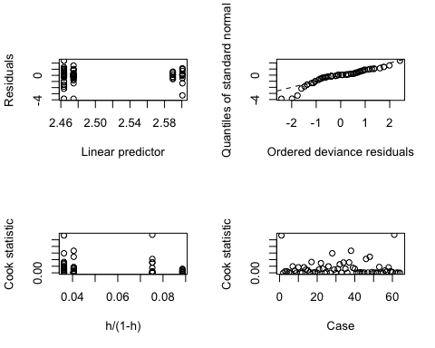

#heavy left tail

# try incorporate random effects

rich_36_nbmm_b=glmer.nb(Richness_change_pos~Treatment+(1|Plot_number/Quadrat_number), data=rich_fenced_36)

## Warning in theta.ml(Y, mu, weights = object@resp$weights, limit = limit, :  
## iteration limit reached

summary(rich_36_nbmm_b)

## Generalized linear mixed model fit by maximum likelihood (Laplace  
## Approximation) [glmerMod]  
## Family: Negative Binomial(2016.488) ( log )  
## Formula: Richness_change_pos ~ Treatment + (1 | Plot_number/Quadrat_number)  
## Data: rich_fenced_36  
##   
## AIC BIC logLik deviance df.resid   
## 417.4 428.2 -203.7 407.4 59   
##   
## Scaled residuals:   
## Min 1Q Median 3Q Max   
## -2.47774 -0.16642 0.03959 0.37387 1.24125   
##   
## Random effects:  
## Groups Name Variance Std.Dev.  
## Quadrat_number:Plot_number (Intercept) 0.108936 0.33006   
## Plot_number (Intercept) 0.002549 0.05049   
## Number of obs: 64, groups: Quadrat_number:Plot_number, 64; Plot_number, 4  
##   
## Fixed effects:  
## Estimate Std. Error z value Pr(>|z|)   
## (Intercept) 2.46567 0.08646 28.518 <2e-16 ***  
## TreatmentRadial -0.03062 0.12144 -0.252 0.801   
## ---  
## Signif. codes: 0 '***' 0.001 '**' 0.01 '*' 0.05 '.' 0.1 ' ' 1  
##   
## Correlation of Fixed Effects:  
## (Intr)  
## TreatmntRdl -0.696

#test the significance of random effect  
LRT = 2 * (-logLik(rich_36_nbmm_b)) - 2 * (-logLik(rich_36_nb_b))  
LRT

## 'log Lik.' 3.28722 (df=5)

pchisq(as.numeric(LRT), df=2, lower.tail=F)

## [1] 0.1932811

#not significant

#Year 0 to 6 (Choose Negative Binomial GLM*)

#Linear model  
rich_06_lm_a=lm(Richness_change~Treatment+Quadrat_gap, rich_fenced_06)  
summary(rich_06_lm_a)

##   
## Call:  
## lm(formula = Richness_change ~ Treatment + Quadrat_gap, data = rich_fenced_06)  
##   
## Residuals:  
## Min 1Q Median 3Q Max   
## -9.7049 -3.1118 -0.7049 3.0369 10.9508   
##   
## Coefficients:  
## Estimate Std. Error t value Pr(>|t|)  
## (Intercept) -1.9508 1.2336 -1.581 0.119  
## TreatmentRadial -1.4052 1.1761 -1.195 0.237  
## Quadrat_gapTrue -0.3443 1.3315 -0.259 0.797  
##   
## Residual standard error: 4.678 on 61 degrees of freedom  
## Multiple R-squared: 0.02521, Adjusted R-squared: -0.006749   
## F-statistic: 0.7888 on 2 and 61 DF, p-value: 0.4589

plot(rich_06_lm_a)

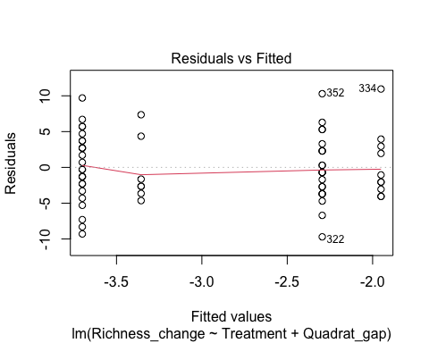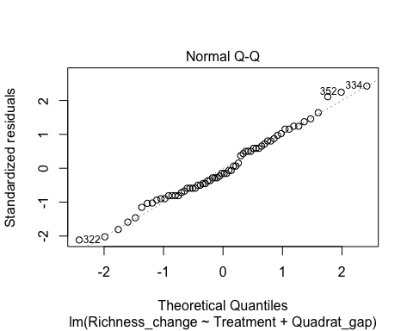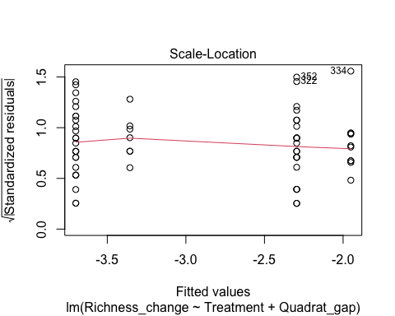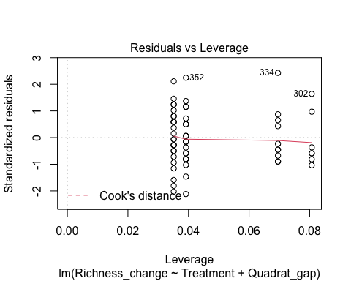

rich_06_lm_b=lm(Richness_change~Treatment, rich_fenced_06)  
summary(rich_06_lm_b)

##   
## Call:  
## lm(formula = Richness_change ~ Treatment, data = rich_fenced_06)  
##   
## Residuals:  
## Min 1Q Median 3Q Max   
## -9.8125 -2.9531 -0.8125 3.1875 11.1875   
##   
## Coefficients:  
## Estimate Std. Error t value Pr(>|t|)   
## (Intercept) -2.1875 0.8207 -2.665 0.00979 **  
## TreatmentRadial -1.4375 1.1607 -1.239 0.22020   
## ---  
## Signif. codes: 0 '***' 0.001 '**' 0.01 '*' 0.05 '.' 0.1 ' ' 1  
##   
## Residual standard error: 4.643 on 62 degrees of freedom  
## Multiple R-squared: 0.02414, Adjusted R-squared: 0.008403   
## F-statistic: 1.534 on 1 and 62 DF, p-value: 0.2202

#Treatment is not significant

#Poisson GLM  
#manipulate data by adding a constant to every y, so that they are all non-negative  
c=min(rich_fenced_06$Richness_change)  
rich_fenced_06$Richness_change_pos=rich_fenced_06$Richness_change + abs(c)  
  
#visualisation and test if the data is poisson  
hist(rich_fenced_06$Richness_change_pos)

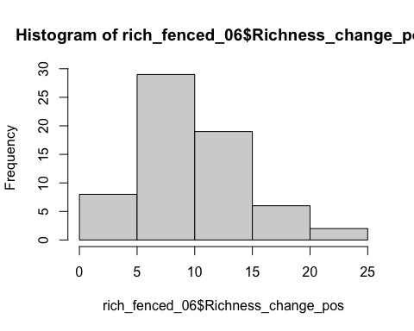

poisson.model3=fitdist(rich_fenced_06$Richness_change_pos,"pois",method=c("mle"))  
poisson.model3

## Fitting of the distribution ' pois ' by maximum likelihood   
## Parameters:  
## estimate Std. Error  
## lambda 10.09375 0.3971333

poisson.lambda3=10.09375   
  
plot(poisson.model3)

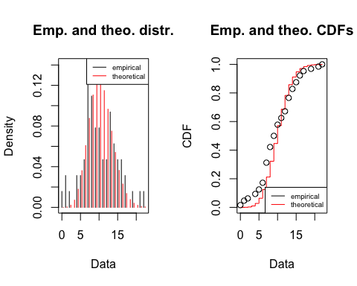

n3=length(rich_fenced_06$Richness_change_pos)  
samp.pct3 <- (1:n3-0.5)/n3  
qqplot(x=qpois(samp.pct3,poisson.lambda3), y=sort(rich_fenced_06$Richness_change_pos), xlab = 'Theoretical quantiles', ylab = 'Empirical quantiles', main='Q-Q plot Poisson')  
abline(0,1,col="red")

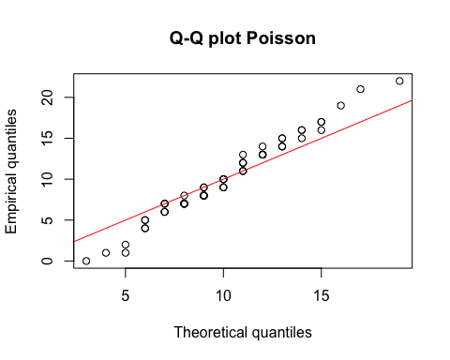

#data has heavier tail than poisson  
  
#fit the model  
rich_06_pois_a=glm(Richness_change_pos~ Treatment + Quadrat_gap, rich_fenced_06, family = poisson)  
summary(rich_06_pois_a)

##   
## Call:  
## glm(formula = Richness_change_pos ~ Treatment + Quadrat_gap,   
## family = poisson, data = rich_fenced_06)  
##   
## Deviance Residuals:   
## Min 1Q Median 3Q Max   
## -4.3140 -1.0170 -0.2159 0.8764 2.8934   
##   
## Coefficients:  
## Estimate Std. Error z value Pr(>|z|)   
## (Intercept) 2.40367 0.08074 29.769 <2e-16 ***  
## TreatmentRadial -0.13948 0.07934 -1.758 0.0787 .   
## Quadrat_gapTrue -0.03358 0.08856 -0.379 0.7045   
## ---  
## Signif. codes: 0 '***' 0.001 '**' 0.01 '*' 0.05 '.' 0.1 ' ' 1  
##   
## (Dispersion parameter for poisson family taken to be 1)  
##   
## Null deviance: 151.94 on 63 degrees of freedom  
## Residual deviance: 148.52 on 61 degrees of freedom  
## AIC: 410.21  
##   
## Number of Fisher Scoring iterations: 4

rich_06_pois_b=glm(Richness_change_pos~Treatment, rich_fenced_06, family = poisson)  
summary(rich_06_pois_b)

##   
## Call:  
## glm(formula = Richness_change_pos ~ Treatment, family = poisson,   
## data = rich_fenced_06)  
##   
## Deviance Residuals:   
## Min 1Q Median 3Q Max   
## -4.3301 -0.9681 -0.2503 0.9268 2.9799   
##   
## Coefficients:  
## Estimate Std. Error z value Pr(>|z|)   
## (Intercept) 2.38070 0.05376 44.284 <2e-16 ***  
## TreatmentRadial -0.14266 0.07889 -1.808 0.0706 .   
## ---  
## Signif. codes: 0 '***' 0.001 '**' 0.01 '*' 0.05 '.' 0.1 ' ' 1  
##   
## (Dispersion parameter for poisson family taken to be 1)  
##   
## Null deviance: 151.94 on 63 degrees of freedom  
## Residual deviance: 148.66 on 62 degrees of freedom  
## AIC: 408.35  
##   
## Number of Fisher Scoring iterations: 4

#goodness of fit  
qchisq(0.95,62)

## [1] 81.38102

#not adequate  
P__disp(rich_06_pois_b)

## pearson.chi2 dispersion   
## 133.288169 2.149809

#very high dispersion (>1)

#Negative Binomial GLM  
#Test if the data is Negative Binomial   
nbinom.model3=fitdist(rich_fenced_06$Richness_change_pos,"nbinom",method=c("mle"))  
nbinom.model3

## Fitting of the distribution ' nbinom ' by maximum likelihood   
## Parameters:  
## estimate Std. Error  
## size 7.502305 2.4980528  
## mu 10.093805 0.6082055

size.nbinom3=7.502305 #first parameter   
mu.nbinom3=10.093805  
prob.nbinom3=size.nbinom3/(size.nbinom3+mu.nbinom3)   
prob.nbinom3

## [1] 0.4263616

plot(nbinom.model3)

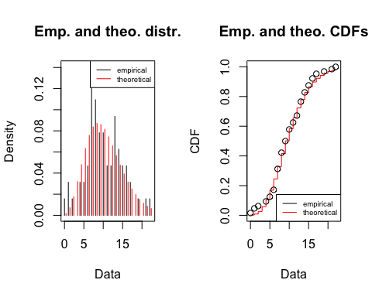

qqplot(x=qnbinom(samp.pct3,size.nbinom3,prob.nbinom3), y=sort(rich_fenced_06$Richness_change_pos), xlab = 'Theoretical quantiles', ylab = 'Empirical quantiles', main='Q-Q plot Negative Binomial')  
abline(0,1,col="red")

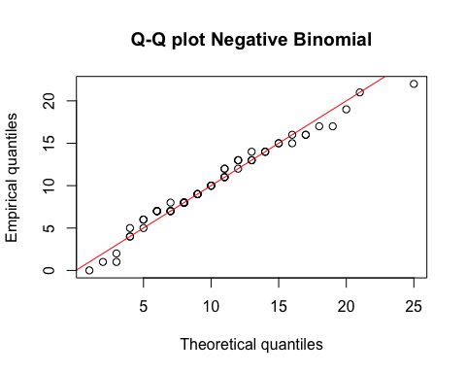

#looks moderately good  
  
#fit the model  
rich_06_nb_a=glm.nb(Richness_change_pos~Treatment+Quadrat_gap, rich_fenced_06)  
summary(rich_06_nb_a)

##   
## Call:  
## glm.nb(formula = Richness_change_pos ~ Treatment + Quadrat_gap,   
## data = rich_fenced_06, init.theta = 7.865475223, link = log)  
##   
## Deviance Residuals:   
## Min 1Q Median 3Q Max   
## -3.5053 -0.6846 -0.1424 0.5701 1.7518   
##   
## Coefficients:  
## Estimate Std. Error z value Pr(>|z|)   
## (Intercept) 2.40209 0.12402 19.368 <2e-16 ***  
## TreatmentRadial -0.13931 0.11971 -1.164 0.245   
## Quadrat_gapTrue -0.03154 0.13480 -0.234 0.815   
## ---  
## Signif. codes: 0 '***' 0.001 '**' 0.01 '*' 0.05 '.' 0.1 ' ' 1  
##   
## (Dispersion parameter for Negative Binomial(7.8655) family taken to be 1)  
##   
## Null deviance: 74.589 on 63 degrees of freedom  
## Residual deviance: 73.097 on 61 degrees of freedom  
## AIC: 388.08  
##   
## Number of Fisher Scoring iterations: 1  
##   
##   
## Theta: 7.87   
## Std. Err.: 2.68   
##   
## 2 x log-likelihood: -380.078

rich_06_nb_b=glm.nb(Richness_change_pos~Treatment, rich_fenced_06)  
summary(rich_06_nb_b) #choose this model

##   
## Call:  
## glm.nb(formula = Richness_change_pos ~ Treatment, data = rich_fenced_06,   
## init.theta = 7.849949054, link = log)  
##   
## Deviance Residuals:   
## Min 1Q Median 3Q Max   
## -3.5125 -0.6556 -0.1635 0.5857 1.7932   
##   
## Coefficients:  
## Estimate Std. Error z value Pr(>|z|)   
## (Intercept) 2.38070 0.08289 28.721 <2e-16 ***  
## TreatmentRadial -0.14266 0.11910 -1.198 0.231   
## ---  
## Signif. codes: 0 '***' 0.001 '**' 0.01 '*' 0.05 '.' 0.1 ' ' 1  
##   
## (Dispersion parameter for Negative Binomial(7.8499) family taken to be 1)  
##   
## Null deviance: 74.518 on 63 degrees of freedom  
## Residual deviance: 73.083 on 62 degrees of freedom  
## AIC: 386.13  
##   
## Number of Fisher Scoring iterations: 1  
##   
##   
## Theta: 7.85   
## Std. Err.: 2.67   
##   
## 2 x log-likelihood: -380.133

#goodness of fit  
qchisq(0.95,62)

## [1] 81.38102

#Adequate  
#Treatment is not significant  
glm.diag.plots((rich_06_nb_b))

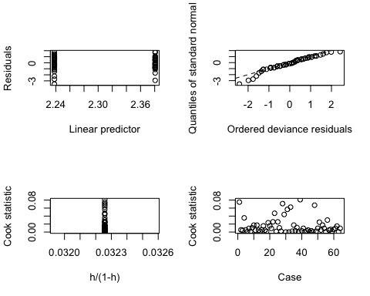

#Heavy left tail

# try incorporate random effects

rich_06_nbmm_b=glmer.nb(Richness_change_pos~Treatment+(1|Plot_number/Quadrat_number), data=rich_fenced_06)

## Warning in theta.ml(Y, mu, weights = object@resp$weights, limit = limit, :  
## iteration limit reached

summary(rich_06_nbmm_b)

## Generalized linear mixed model fit by maximum likelihood (Laplace  
## Approximation) [glmerMod]  
## Family: Negative Binomial(1831.616) ( log )  
## Formula: Richness_change_pos ~ Treatment + (1 | Plot_number/Quadrat_number)  
## Data: rich_fenced_06  
##   
## AIC BIC logLik deviance df.resid   
## 391.7 402.5 -190.8 381.7 59   
##   
## Scaled residuals:   
## Min 1Q Median 3Q Max   
## -2.22191 -0.42083 -0.04417 0.49064 1.11854   
##   
## Random effects:  
## Groups Name Variance Std.Dev.  
## Quadrat_number:Plot_number (Intercept) 0.113148 0.33637   
## Plot_number (Intercept) 0.002629 0.05128   
## Number of obs: 64, groups: Quadrat_number:Plot_number, 64; Plot_number, 4  
##   
## Fixed effects:  
## Estimate Std. Error z value Pr(>|z|)   
## (Intercept) 2.3282 0.0897 25.954 <2e-16 ***  
## TreatmentRadial -0.1514 0.1275 -1.187 0.235   
## ---  
## Signif. codes: 0 '***' 0.001 '**' 0.01 '*' 0.05 '.' 0.1 ' ' 1  
##   
## Correlation of Fixed Effects:  
## (Intr)  
## TreatmntRdl -0.685

#test the significance of random effect  
LRT = 2 * (-logLik(rich_06_nbmm_b)) - 2 * (-logLik(rich_06_nb_b))  
LRT

## 'log Lik.' 1.525299 (df=5)

pchisq(as.numeric(LRT), df=2, lower.tail=F)

## [1] 0.466429

#not significant

# H: Removal of Browsing will cause Species richness to be higher across all treatments (T1 & T2)

## Visualisation

#Year 0 to 3  
rich_03_df=rich_df[rich_df$Time=="0-3",]  
plot(rich_03_df$Richness_change, xlab="32 quadrats for each plot: 7, 9, 10, 12", ylab="change in species richness", main="Change in species richness in fenced and unfenced quadrats from Y0 to Y3 ", col=factor(rich_03_df$Quadrat_fenced))  
abline(h=0, lty=2)  
legend("bottomright", legend = paste(c("unfenced","fenced")), col=c("black","red"), pch=1)

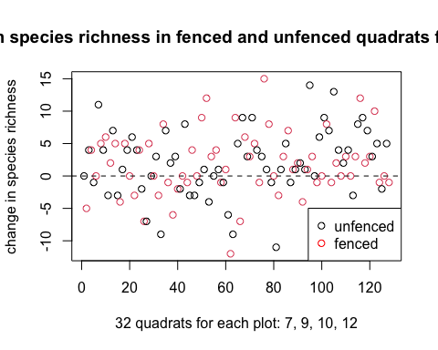

boxplot(rich_03_df$Richness_change~rich_03_df$Quadrat_fenced, xlab="Fenced quadrat?", ylab="Change in species richness", main="Change in species richness from Y0 to Y3")

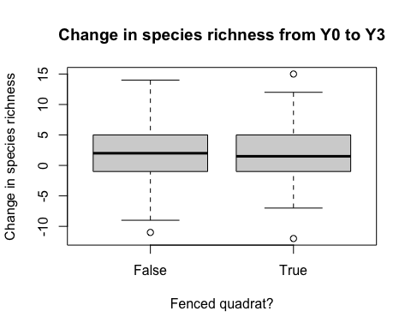

library(ggplot2)  
ggplot(rich_03_df, aes(x=Richness_change, color=Quadrat_fenced)) + geom_histogram(fill="white", position="dodge") + theme(legend.position="top")

## `stat_bin()` using `bins = 30`. Pick better value with `binwidth`.

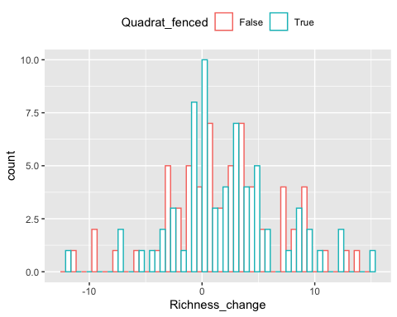

#Year 3 to 6  
rich_36_df=rich_df[rich_df$Time=="3-6",]  
plot(rich_36_df$Richness_change, xlab="32 quadrats for each plot: 7, 9, 10, 12", ylab="change in species richness", main="Change in species richness in fenced and unfenced quadrats from Y3 to Y6 ", col=factor(rich_36_df$Quadrat_fenced))  
abline(h=0, lty=2)  
legend("bottomright", legend = paste(c("unfenced","fenced")), col=c("black","red"), pch=1)

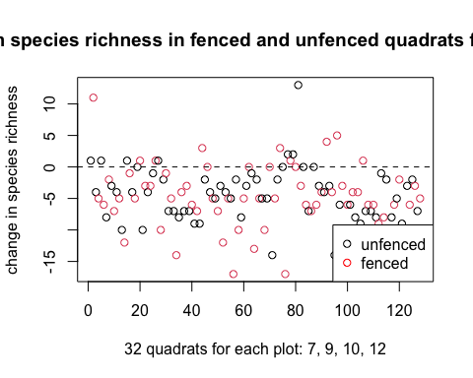

boxplot(rich_36_df$Richness_change~rich_36_df$Quadrat_fenced, xlab="Fenced quadrat?", ylab="Change in species richness", main="Change in species richness from Y3 to Y6")

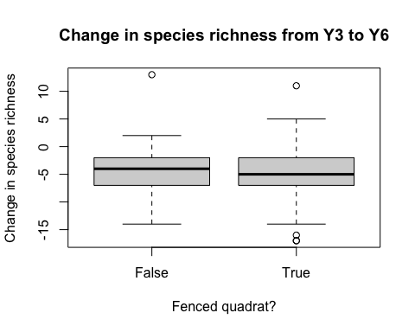

ggplot(rich_36_df, aes(x=Richness_change, color=Quadrat_fenced)) + geom_histogram(fill="white", position="dodge") + theme(legend.position="top")

## `stat_bin()` using `bins = 30`. Pick better value with `binwidth`.

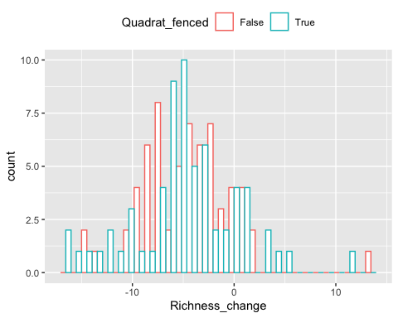

#Year 0 to 6  
rich_06_df=rich_df[rich_df$Time=="0-6",]  
plot(rich_06_df$Richness_change, xlab="32 quadrats for each plot: 7, 9, 10, 12", ylab="change in species richness", main="Change in species richness in fenced and unfenced quadrats from Y0 to Y6 ", col=factor(rich_06_df$Quadrat_fenced))  
abline(h=0, lty=2)  
legend("bottomright", legend = paste(c("unfenced","fenced")), col=c("black","red"), pch=1)

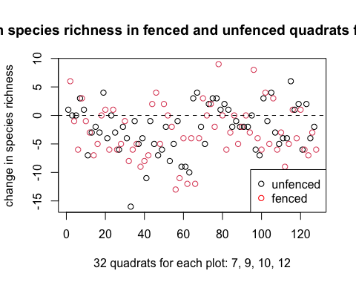

boxplot(rich_06_df$Richness_change~rich_06_df$Quadrat_fenced, xlab="Fenced quadrat?", ylab="Change in species richness", main="Change in species richness from Y0 to Y6")

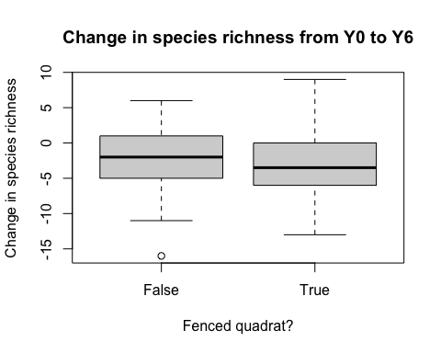

ggplot(rich_06_df, aes(x=Richness_change, color=Quadrat_fenced)) + geom_histogram(fill="white", position="dodge") + theme(legend.position="top")

## `stat_bin()` using `bins = 30`. Pick better value with `binwidth`.

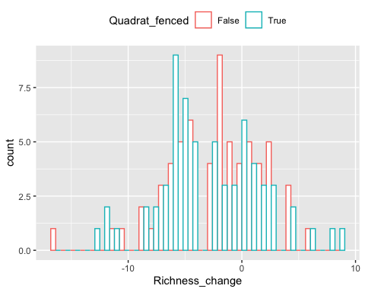

## Modelling

### Y0 to 3 (choose Negative Binomial GLM)

# Linear model  
rich_03_lm_h2a=lm(Richness_change~Quadrat_fenced+Treatment+Quadrat_gap,data=rich_03_df)  
summary(rich_03_lm_h2a)

##   
## Call:  
## lm(formula = Richness_change ~ Quadrat_fenced + Treatment + Quadrat_gap,   
## data = rich_03_df)  
##   
## Residuals:  
## Min 1Q Median 3Q Max   
## -13.4936 -2.9423 -0.5288 3.1151 11.4399   
##   
## Coefficients:  
## Estimate Std. Error t value Pr(>|t|)   
## (Intercept) 2.4936 0.8653 2.882 0.00466 **  
## Quadrat_fencedTrue -0.5044 0.8730 -0.578 0.56450   
## TreatmentRadial -2.5669 0.8730 -2.940 0.00391 **  
## Quadrat_gapTrue 1.5709 0.9294 1.690 0.09351 .   
## ---  
## Signif. codes: 0 '***' 0.001 '**' 0.01 '*' 0.05 '.' 0.1 ' ' 1  
##   
## Residual standard error: 4.855 on 124 degrees of freedom  
## Multiple R-squared: 0.07527, Adjusted R-squared: 0.0529   
## F-statistic: 3.364 on 3 and 124 DF, p-value: 0.02089

plot(rich_03_lm_h2a)

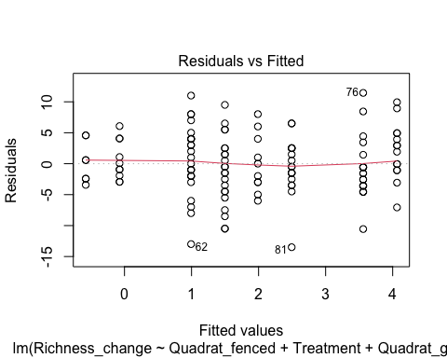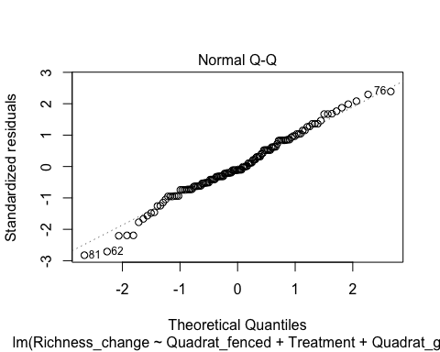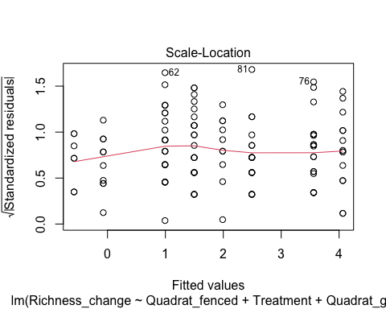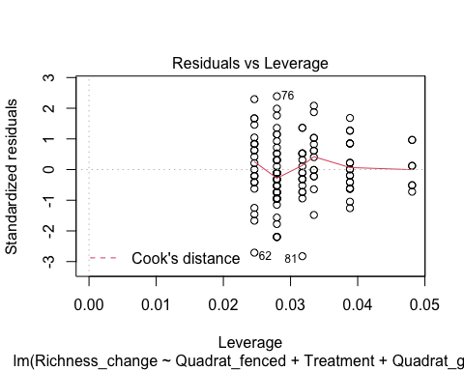

rich_03_lm_h2b=lm(Richness_change~Quadrat_fenced+Treatment,rich_03_df)  
summary(rich_03_lm_h2b)

##   
## Call:  
## lm(formula = Richness_change ~ Quadrat_fenced + Treatment, data = rich_03_df)  
##   
## Residuals:  
## Min 1Q Median 3Q Max   
## -14.2422 -3.0078 -0.2422 3.2891 11.9922   
##   
## Coefficients:  
## Estimate Std. Error t value Pr(>|t|)   
## (Intercept) 3.2422 0.7488 4.330 3.03e-05 ***  
## Quadrat_fencedTrue -0.2344 0.8646 -0.271 0.78678   
## TreatmentRadial -2.2969 0.8646 -2.656 0.00893 **   
## ---  
## Signif. codes: 0 '***' 0.001 '**' 0.01 '*' 0.05 '.' 0.1 ' ' 1  
##   
## Residual standard error: 4.891 on 125 degrees of freedom  
## Multiple R-squared: 0.05396, Adjusted R-squared: 0.03883   
## F-statistic: 3.565 on 2 and 125 DF, p-value: 0.0312

plot(rich_03_lm_h2b)

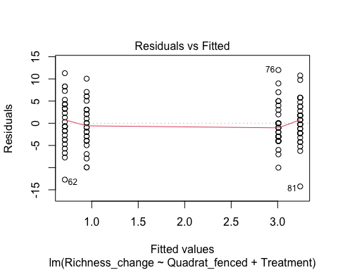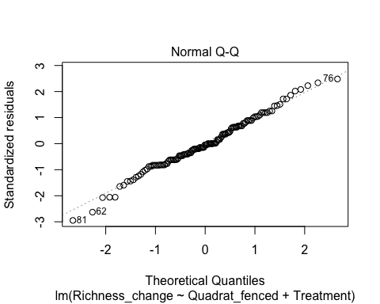

## hat values (leverages) are all = 0.0234375  
## and there are no factor predictors; no plot no. 5

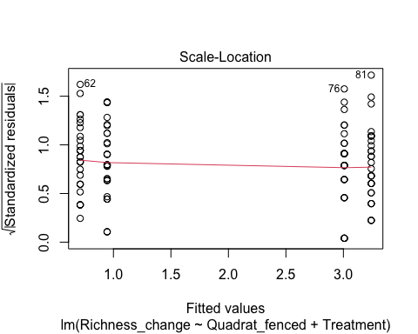

anova(rich_03_lm_h2b,rich_03_lm_h2a)

## Analysis of Variance Table  
##   
## Model 1: Richness_change ~ Quadrat_fenced + Treatment  
## Model 2: Richness_change ~ Quadrat_fenced + Treatment + Quadrat_gap  
## Res.Df RSS Df Sum of Sq F Pr(>F)   
## 1 125 2990.3   
## 2 124 2923.0 1 67.338 2.8566 0.09351 .  
## ---  
## Signif. codes: 0 '***' 0.001 '**' 0.01 '*' 0.05 '.' 0.1 ' ' 1

rich_03_lm_h2c=lm(Richness_change~Treatment,rich_03_df)  
summary(rich_03_lm_h2c)

##   
## Call:  
## lm(formula = Richness_change ~ Treatment, data = rich_03_df)  
##   
## Residuals:  
## Min 1Q Median 3Q Max   
## -14.125 -3.125 -0.125 3.172 11.875   
##   
## Coefficients:  
## Estimate Std. Error t value Pr(>|t|)   
## (Intercept) 3.1250 0.6091 5.130 1.06e-06 ***  
## TreatmentRadial -2.2969 0.8614 -2.666 0.00867 **   
## ---  
## Signif. codes: 0 '***' 0.001 '**' 0.01 '*' 0.05 '.' 0.1 ' ' 1  
##   
## Residual standard error: 4.873 on 126 degrees of freedom  
## Multiple R-squared: 0.05341, Adjusted R-squared: 0.0459   
## F-statistic: 7.109 on 1 and 126 DF, p-value: 0.008675

plot(rich_03_lm_h2c)

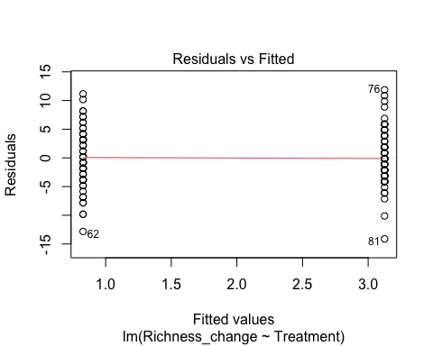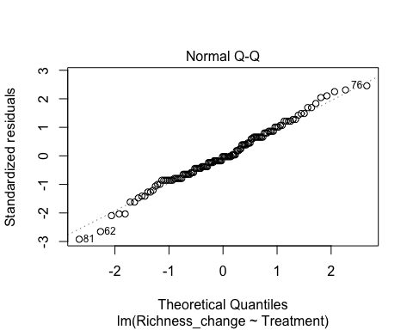

## hat values (leverages) are all = 0.015625  
## and there are no factor predictors; no plot no. 5

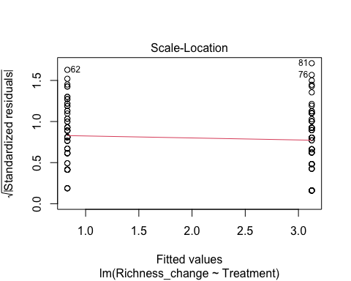

anova(rich_03_lm_h2c,rich_03_lm_h2b)

## Analysis of Variance Table  
##   
## Model 1: Richness_change ~ Treatment  
## Model 2: Richness_change ~ Quadrat_fenced + Treatment  
## Res.Df RSS Df Sum of Sq F Pr(>F)  
## 1 126 2992.1   
## 2 125 2990.3 1 1.7578 0.0735 0.7868

#Quadrat_fenced is not significant

#Poisson GLM  
#manipulate data by adding a constant to every y, so that they are all non-negative  
z=min(rich_03_df$Richness_change)  
rich_03_df$Richness_change_pos=rich_03_df$Richness_change + abs(z)  
  
#visualisation and test if the data is poisson  
hist(rich_03_df$Richness_change_pos)

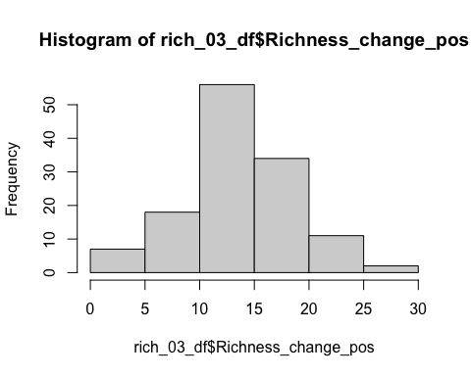

poisson.model4=fitdist(rich_03_df$Richness_change_pos,"pois",method=c("mle"))  
poisson.model4

## Fitting of the distribution ' pois ' by maximum likelihood   
## Parameters:  
## estimate Std. Error  
## lambda 13.97656 0.330442

poisson.lambda4=13.97656  
  
plot(poisson.model4)

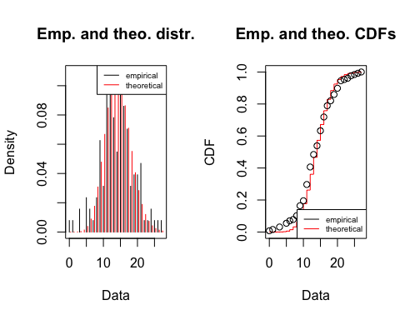

n4=length(rich_03_df$Richness_change_pos)  
samp.pct4 <- (1:n4-0.5)/n4  
qqplot(x=qpois(samp.pct4,poisson.lambda4), y=sort(rich_03_df$Richness_change_pos), xlab = 'Theoretical quantiles', ylab = 'Empirical quantiles', main='Q-Q plot Poisson')  
abline(0,1,col="red")

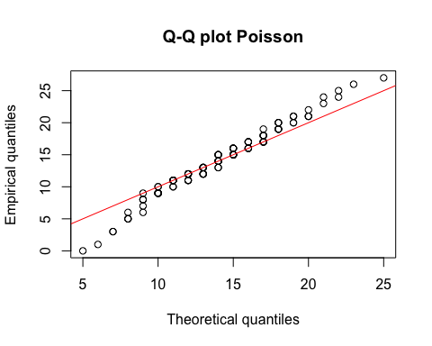

#data has heavier tails than Poisson  
  
#fit the model  
rich_03_pois_h2a=glm(Richness_change_pos~Quadrat_fenced+Treatment+Quadrat_gap, rich_03_df, family = poisson)  
summary(rich_03_pois_h2a)

##   
## Call:  
## glm(formula = Richness_change_pos ~ Quadrat_fenced + Treatment +   
## Quadrat_gap, family = poisson, data = rich_03_df)  
##   
## Deviance Residuals:   
## Min 1Q Median 3Q Max   
## -5.0917 -0.8118 -0.1355 0.8194 2.7372   
##   
## Coefficients:  
## Estimate Std. Error z value Pr(>|z|)   
## (Intercept) 2.66949 0.04756 56.133 < 2e-16 ***  
## Quadrat_fencedTrue -0.03672 0.04814 -0.763 0.445587   
## TreatmentRadial -0.18400 0.04824 -3.815 0.000136 ***  
## Quadrat_gapTrue 0.11330 0.05179 2.188 0.028682 *   
## ---  
## Signif. codes: 0 '***' 0.001 '**' 0.01 '*' 0.05 '.' 0.1 ' ' 1  
##   
## (Dispersion parameter for poisson family taken to be 1)  
##   
## Null deviance: 253.96 on 127 degrees of freedom  
## Residual deviance: 236.90 on 124 degrees of freedom  
## AIC: 806.24  
##   
## Number of Fisher Scoring iterations: 4

#goodness of fit  
qchisq(0.95,124)

## [1] 150.9894

#inadequate  
P__disp(rich_03_pois_h2a)

## pearson.chi2 dispersion   
## 209.299038 1.687895

rich_03_pois_h2b=glm(Richness_change_pos~Treatment+Quadrat_gap, rich_03_df, family = poisson)  
summary(rich_03_pois_h2b) #choose this

##   
## Call:  
## glm(formula = Richness_change_pos ~ Treatment + Quadrat_gap,   
## family = poisson, data = rich_03_df)  
##   
## Deviance Residuals:   
## Min 1Q Median 3Q Max   
## -5.1342 -0.8665 -0.1347 0.7746 2.6700   
##   
## Coefficients:  
## Estimate Std. Error z value Pr(>|z|)   
## (Intercept) 2.65540 0.04392 60.464 < 2e-16 ***  
## TreatmentRadial -0.18262 0.04819 -3.789 0.000151 ***  
## Quadrat_gapTrue 0.10591 0.05087 2.082 0.037318 *   
## ---  
## Signif. codes: 0 '***' 0.001 '**' 0.01 '*' 0.05 '.' 0.1 ' ' 1  
##   
## (Dispersion parameter for poisson family taken to be 1)  
##   
## Null deviance: 253.96 on 127 degrees of freedom  
## Residual deviance: 237.48 on 125 degrees of freedom  
## AIC: 804.82  
##   
## Number of Fisher Scoring iterations: 4

#goodness of fit  
qchisq(0.95,125)

## [1] 152.0939

#inadequate  
  
anova(rich_03_pois_h2b,rich_03_pois_h2a)

## Analysis of Deviance Table  
##   
## Model 1: Richness_change_pos ~ Treatment + Quadrat_gap  
## Model 2: Richness_change_pos ~ Quadrat_fenced + Treatment + Quadrat_gap  
## Resid. Df Resid. Dev Df Deviance  
## 1 125 237.48   
## 2 124 236.90 1 0.58185

qchisq(0.95,1)

## [1] 3.841459

# Quadrat_fenced is not significant

#Negative Binomial GLM  
#Test if the data is Negative Binomial   
nbinom.model4=fitdist(rich_03_df$Richness_change_pos,"nbinom",method=c("mle"))  
nbinom.model4

## Fitting of the distribution ' nbinom ' by maximum likelihood   
## Parameters:  
## estimate Std. Error  
## size 15.42857 4.3597879  
## mu 13.97705 0.4562113

size.nbinom4=15.42857 #first parameter   
mu.nbinom4=13.97705  
prob.nbinom4=size.nbinom4/(size.nbinom4+mu.nbinom4)   
prob.nbinom4

## [1] 0.524681

plot(nbinom.model4)

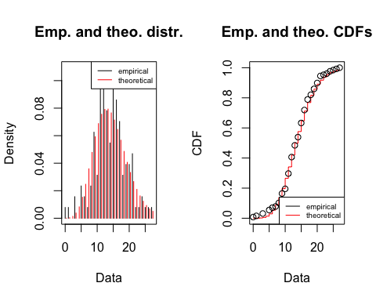

qqplot(x=qnbinom(samp.pct4,size.nbinom4,prob.nbinom4), y=sort(rich_03_df$Richness_change_pos), xlab = 'Theoretical quantiles', ylab = 'Empirical quantiles', main='Q-Q plot Negative Binomial')  
abline(0,1,col="red")

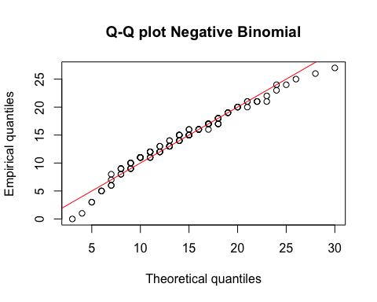

#look ok  
  
#fit the model  
rich_03_nb_h2a=glm.nb(Richness_change_pos~Quadrat_fenced+Treatment+Quadrat_gap, rich_03_df)  
summary(rich_03_nb_h2a)

##   
## Call:  
## glm.nb(formula = Richness_change_pos ~ Quadrat_fenced + Treatment +   
## Quadrat_gap, data = rich_03_df, init.theta = 18.63365684,   
## link = log)  
##   
## Deviance Residuals:   
## Min 1Q Median 3Q Max   
## -4.4399 -0.6394 -0.0997 0.6092 1.9982   
##   
## Coefficients:  
## Estimate Std. Error z value Pr(>|z|)   
## (Intercept) 2.66817 0.06301 42.346 < 2e-16 ***  
## Quadrat_fencedTrue -0.03261 0.06373 -0.512 0.60892   
## TreatmentRadial -0.18234 0.06377 -2.859 0.00424 **   
## Quadrat_gapTrue 0.11099 0.06826 1.626 0.10396   
## ---  
## Signif. codes: 0 '***' 0.001 '**' 0.01 '*' 0.05 '.' 0.1 ' ' 1  
##   
## (Dispersion parameter for Negative Binomial(18.6337) family taken to be 1)  
##   
## Null deviance: 155.55 on 127 degrees of freedom  
## Residual deviance: 145.93 on 124 degrees of freedom  
## AIC: 787.82  
##   
## Number of Fisher Scoring iterations: 1  
##   
##   
## Theta: 18.63   
## Std. Err.: 5.89   
##   
## 2 x log-likelihood: -777.824

#goodness of fit  
qchisq(0.95,124)

## [1] 150.9894

#Adequate  
  
rich_03_nb_h2b=glm.nb(Richness_change_pos~Quadrat_fenced+Treatment, rich_03_df)  
summary(rich_03_nb_h2b) #choose this model

##   
## Call:  
## glm.nb(formula = Richness_change_pos ~ Quadrat_fenced + Treatment,   
## data = rich_03_df, init.theta = 17.58881958, link = log)  
##   
## Deviance Residuals:   
## Min 1Q Median 3Q Max   
## -4.3780 -0.6234 -0.0429 0.6574 2.0337   
##   
## Coefficients:  
## Estimate Std. Error z value Pr(>|z|)   
## (Intercept) 2.72312 0.05403 50.403 < 2e-16 ***  
## Quadrat_fencedTrue -0.01385 0.06340 -0.218 0.82712   
## TreatmentRadial -0.16446 0.06347 -2.591 0.00956 **   
## ---  
## Signif. codes: 0 '***' 0.001 '**' 0.01 '*' 0.05 '.' 0.1 ' ' 1  
##   
## (Dispersion parameter for Negative Binomial(17.5888) family taken to be 1)  
##   
## Null deviance: 152.19 on 127 degrees of freedom  
## Residual deviance: 145.40 on 125 degrees of freedom  
## AIC: 788.45  
##   
## Number of Fisher Scoring iterations: 1  
##   
##   
## Theta: 17.59   
## Std. Err.: 5.36   
##   
## 2 x log-likelihood: -780.45

#goodness of fit  
qchisq(0.95,125)

## [1] 152.0939

#Adequate  
anova(rich_03_nb_h2b,rich_03_nb_h2a)

## Likelihood ratio tests of Negative Binomial Models  
##   
## Response: Richness_change_pos  
## Model theta Resid. df 2 x log-lik.  
## 1 Quadrat_fenced + Treatment 17.58882 125 -780.4498  
## 2 Quadrat_fenced + Treatment + Quadrat_gap 18.63366 124 -777.8243  
## Test df LR stat. Pr(Chi)  
## 1   
## 2 1 vs 2 1 2.625525 0.1051577

rich_03_nb_h2c=glm.nb(Richness_change_pos~Treatment, rich_03_df)  
summary(rich_03_nb_h2c)

##   
## Call:  
## glm.nb(formula = Richness_change_pos ~ Treatment, data = rich_03_df,   
## init.theta = 17.56239179, link = log)  
##   
## Deviance Residuals:   
## Min 1Q Median 3Q Max   
## -4.3888 -0.6251 -0.0236 0.6376 2.0111   
##   
## Coefficients:  
## Estimate Std. Error z value Pr(>|z|)   
## (Intercept) 2.71635 0.04385 61.948 < 2e-16 ***  
## TreatmentRadial -0.16471 0.06349 -2.594 0.00948 **   
## ---  
## Signif. codes: 0 '***' 0.001 '**' 0.01 '*' 0.05 '.' 0.1 ' ' 1  
##   
## (Dispersion parameter for Negative Binomial(17.5624) family taken to be 1)  
##   
## Null deviance: 152.10 on 127 degrees of freedom  
## Residual deviance: 145.36 on 126 degrees of freedom  
## AIC: 786.5  
##   
## Number of Fisher Scoring iterations: 1  
##   
##   
## Theta: 17.56   
## Std. Err.: 5.35   
##   
## 2 x log-likelihood: -780.497

#goodness of fit  
qchisq(0.95,126)

## [1] 153.1979

#Adequate  
anova(rich_03_nb_h2c,rich_03_nb_h2b)

## Likelihood ratio tests of Negative Binomial Models  
##   
## Response: Richness_change_pos  
## Model theta Resid. df 2 x log-lik. Test df  
## 1 Treatment 17.56239 126 -780.4974   
## 2 Quadrat_fenced + Treatment 17.58882 125 -780.4498 1 vs 2 1  
## LR stat. Pr(Chi)  
## 1   
## 2 0.0476575 0.8271907

#Quadrat_fenced is not significant

# try incorporate random effects

rich_03_nbmm_h2b=glmer.nb(Richness_change_pos~Quadrat_fenced+Treatment+(1|Plot_number/Quadrat_number), data=rich_03_df)

## Warning in theta.ml(Y, mu, weights = object@resp$weights, limit = limit, :  
## iteration limit reached

## boundary (singular) fit: see ?isSingular

summary(rich_03_nbmm_h2b)

## Generalized linear mixed model fit by maximum likelihood (Laplace  
## Approximation) [glmerMod]  
## Family: Negative Binomial(2271.504) ( log )  
## Formula:   
## Richness_change_pos ~ Quadrat_fenced + Treatment + (1 | Plot_number/Quadrat_number)  
## Data: rich_03_df  
##   
## AIC BIC logLik deviance df.resid   
## 794.0 811.1 -391.0 782.0 122   
##   
## Scaled residuals:   
## Min 1Q Median 3Q Max   
## -2.85134 -0.44026 0.01856 0.55705 1.58236   
##   
## Random effects:  
## Groups Name Variance Std.Dev.   
## Quadrat_number:Plot_number (Intercept) 5.143e-02 2.268e-01  
## Plot_number (Intercept) 5.743e-11 7.578e-06  
## Number of obs: 128, groups: Quadrat_number:Plot_number, 128; Plot_number, 4  
##   
## Fixed effects:  
## Estimate Std. Error z value Pr(>|z|)   
## (Intercept) 2.69957 0.05334 50.615 < 2e-16 ***  
## Quadrat_fencedTrue -0.01440 0.06243 -0.231 0.81754   
## TreatmentRadial -0.16789 0.06252 -2.685 0.00724 **   
## ---  
## Signif. codes: 0 '***' 0.001 '**' 0.01 '*' 0.05 '.' 0.1 ' ' 1  
##   
## Correlation of Fixed Effects:  
## (Intr) Qdrt_T  
## Qdrt_fncdTr -0.578   
## TreatmntRdl -0.549 -0.010  
## optimizer (Nelder_Mead) convergence code: 0 (OK)  
## boundary (singular) fit: see ?isSingular

#test the significance of random effect  
LRT = 2 * (-logLik(rich_03_nbmm_h2b)) - 2 * (-logLik(rich_03_nb_h2b))  
LRT

## 'log Lik.' 1.561141 (df=6)

pchisq(as.numeric(LRT), df=2, lower.tail=F)

## [1] 0.4581445

#not significant

### Y3 to 6 (Choose Negative Binomial GLM*)

# Linear model  
rich_36_lm_h2a=lm(Richness_change~Quadrat_fenced+Treatment+Quadrat_gap,data=rich_36_df)  
summary(rich_36_lm_h2a)

##   
## Call:  
## lm(formula = Richness_change ~ Quadrat_fenced + Treatment + Quadrat_gap,   
## data = rich_36_df)  
##   
## Residuals:  
## Min 1Q Median 3Q Max   
## -12.6421 -2.6658 0.1608 3.0656 16.3342   
##   
## Coefficients:  
## Estimate Std. Error t value Pr(>|t|)   
## (Intercept) -3.3342 0.8444 -3.948 0.000131 ***  
## Quadrat_fencedTrue -0.0237 0.8520 -0.028 0.977854   
## TreatmentRadial 0.3201 0.8520 0.376 0.707826   
## Quadrat_gapTrue -2.1348 0.9071 -2.354 0.020165 *   
## ---  
## Signif. codes: 0 '***' 0.001 '**' 0.01 '*' 0.05 '.' 0.1 ' ' 1  
##   
## Residual standard error: 4.738 on 124 degrees of freedom  
## Multiple R-squared: 0.04439, Adjusted R-squared: 0.02127   
## F-statistic: 1.92 on 3 and 124 DF, p-value: 0.1298

plot(rich_36_lm_h2a)

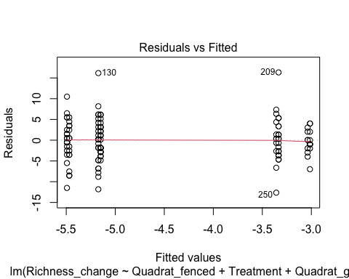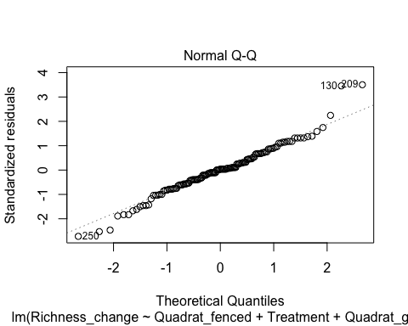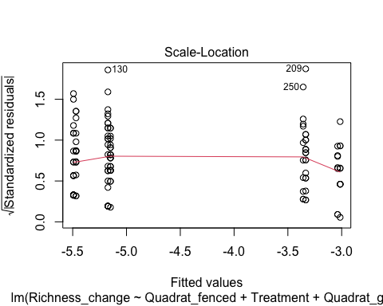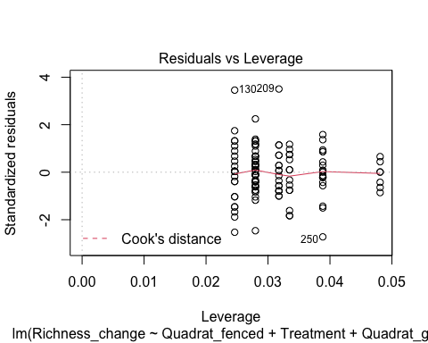

rich_36_lm_h2b=lm(Richness_change~Quadrat_fenced+Quadrat_gap,rich_36_df)  
summary(rich_36_lm_h2b)

##   
## Call:  
## lm(formula = Richness_change ~ Quadrat_fenced + Quadrat_gap,   
## data = rich_36_df)  
##   
## Residuals:  
## Min 1Q Median 3Q Max   
## -12.7564 -2.7183 0.2436 3.2092 16.3161   
##   
## Coefficients:  
## Estimate Std. Error t value Pr(>|t|)   
## (Intercept) -3.20922 0.77348 -4.149 6.12e-05 ***  
## Quadrat_fencedTrue -0.03441 0.84861 -0.041 0.9677   
## Quadrat_gapTrue -2.07250 0.88867 -2.332 0.0213 *   
## ---  
## Signif. codes: 0 '***' 0.001 '**' 0.01 '*' 0.05 '.' 0.1 ' ' 1  
##   
## Residual standard error: 4.722 on 125 degrees of freedom  
## Multiple R-squared: 0.0433, Adjusted R-squared: 0.028   
## F-statistic: 2.829 on 2 and 125 DF, p-value: 0.06287

plot(rich_36_lm_h2b)

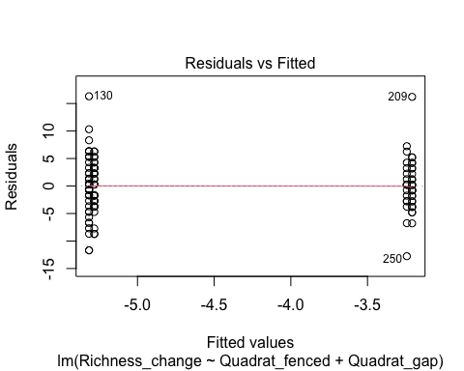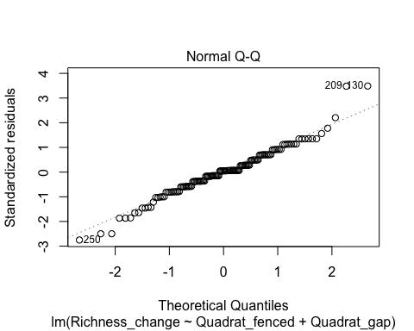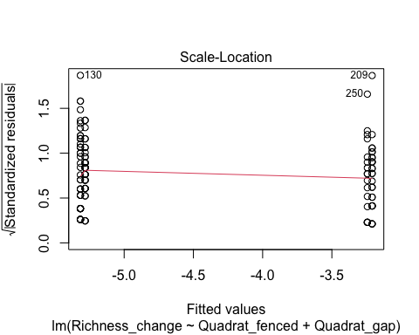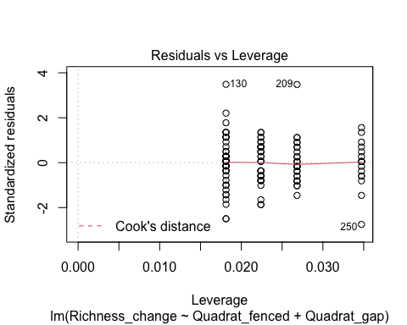

anova(rich_36_lm_h2b,rich_36_lm_h2a)

## Analysis of Variance Table  
##   
## Model 1: Richness_change ~ Quadrat_fenced + Quadrat_gap  
## Model 2: Richness_change ~ Quadrat_fenced + Treatment + Quadrat_gap  
## Res.Df RSS Df Sum of Sq F Pr(>F)  
## 1 125 2787.2   
## 2 124 2784.0 1 3.1681 0.1411 0.7078

rich_36_lm_h2c=lm(Richness_change~Quadrat_gap,rich_36_df)  
summary(rich_36_lm_h2c)

##   
## Call:  
## lm(formula = Richness_change ~ Quadrat_gap, data = rich_36_df)  
##   
## Residuals:  
## Min 1Q Median 3Q Max   
## -12.7778 -2.6988 0.2222 3.2222 16.3012   
##   
## Coefficients:  
## Estimate Std. Error t value Pr(>|t|)   
## (Intercept) -3.2222 0.7011 -4.596 1.03e-05 ***  
## Quadrat_gapTrue -2.0790 0.8707 -2.388 0.0184 *   
## ---  
## Signif. codes: 0 '***' 0.001 '**' 0.01 '*' 0.05 '.' 0.1 ' ' 1  
##   
## Residual standard error: 4.703 on 126 degrees of freedom  
## Multiple R-squared: 0.04329, Adjusted R-squared: 0.0357   
## F-statistic: 5.701 on 1 and 126 DF, p-value: 0.01844

plot(rich_36_lm_h2c)

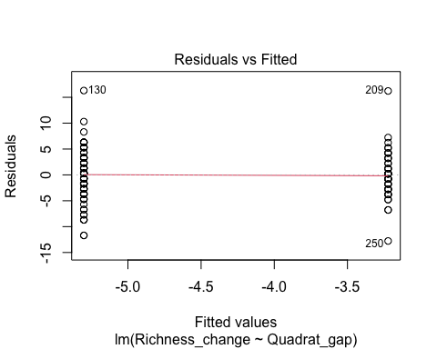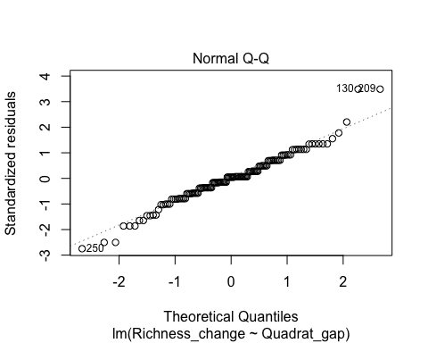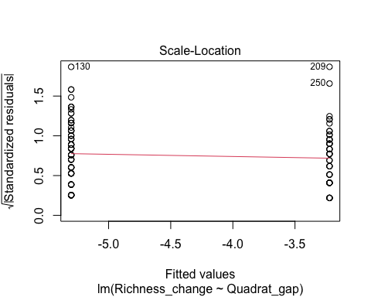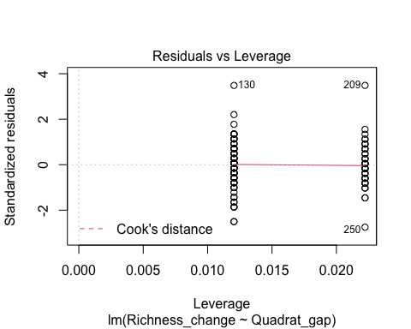

anova(rich_36_lm_h2c,rich_36_lm_h2b)

## Analysis of Variance Table  
##   
## Model 1: Richness_change ~ Quadrat_gap  
## Model 2: Richness_change ~ Quadrat_fenced + Quadrat_gap  
## Res.Df RSS Df Sum of Sq F Pr(>F)  
## 1 126 2787.2   
## 2 125 2787.2 1 0.036672 0.0016 0.9677

#Quadrat_fenced is not significant

#Poisson GLM  
#manipulate data by adding a constant to every y, so that they are all non-negative  
w=min(rich_36_df$Richness_change)  
rich_36_df$Richness_change_pos=rich_36_df$Richness_change + abs(w)  
  
#visualisation and test if the data is poisson  
hist(rich_36_df$Richness_change_pos)

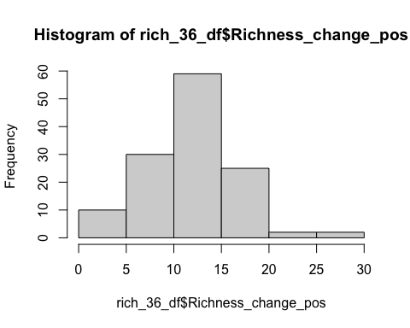

poisson.model5=fitdist(rich_36_df$Richness_change_pos,"pois",method=c("mle"))  
poisson.model5

## Fitting of the distribution ' pois ' by maximum likelihood   
## Parameters:  
## estimate Std. Error  
## lambda 12.42969 0.3116199

poisson.lambda5=12.42969   
  
plot(poisson.model5)

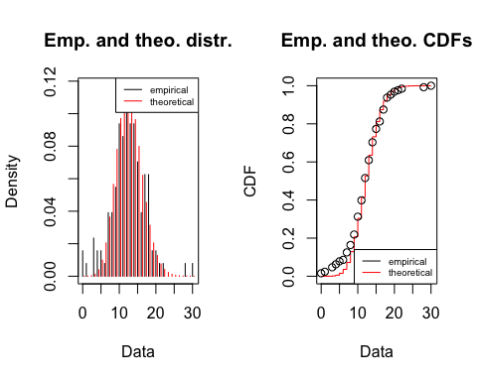

n5=length(rich_36_df$Richness_change_pos)  
samp.pct5 <- (1:n5-0.5)/n5  
qqplot(x=qpois(samp.pct5,poisson.lambda5), y=sort(rich_36_df$Richness_change_pos), xlab = 'Theoretical quantiles', ylab = 'Empirical quantiles', main='Q-Q plot Poisson')  
abline(0,1,col="red")

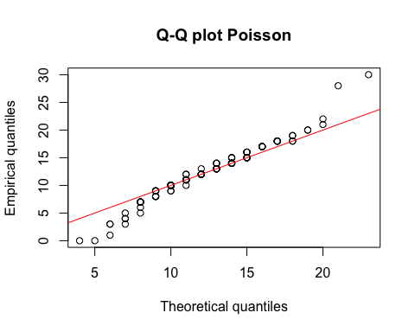

#fit the model  
rich_36_pois_h2a=glm(Richness_change_pos~Quadrat_fenced+Treatment+Quadrat_gap, rich_36_df, family = poisson)  
summary(rich_36_pois_h2a)

##   
## Call:  
## glm(formula = Richness_change_pos ~ Quadrat_fenced + Treatment +   
## Quadrat_gap, family = poisson, data = rich_36_df)  
##   
## Deviance Residuals:   
## Min 1Q Median 3Q Max   
## -4.8619 -0.7734 0.0490 0.8033 3.9922   
##   
## Coefficients:  
## Estimate Std. Error z value Pr(>|z|)   
## (Intercept) 2.614005 0.048879 53.479 < 2e-16 ***  
## Quadrat_fencedTrue -0.002043 0.051029 -0.040 0.96806   
## TreatmentRadial 0.025796 0.051034 0.505 0.61323   
## Quadrat_gapTrue -0.168053 0.053221 -3.158 0.00159 **   
## ---  
## Signif. codes: 0 '***' 0.001 '**' 0.01 '*' 0.05 '.' 0.1 ' ' 1  
##   
## (Dispersion parameter for poisson family taken to be 1)  
##   
## Null deviance: 266.45 on 127 degrees of freedom  
## Residual deviance: 256.20 on 124 degrees of freedom  
## AIC: 806.95  
##   
## Number of Fisher Scoring iterations: 4

#goodness of fit  
qchisq(0.95,124)

## [1] 150.9894

#inadequate  
  
rich_36_pois_h2b=glm(Richness_change_pos~Quadrat_fenced+Quadrat_gap, rich_36_df, family = poisson)  
summary(rich_36_pois_h2b)

##   
## Call:  
## glm(formula = Richness_change_pos ~ Quadrat_fenced + Quadrat_gap,   
## family = poisson, data = rich_36_df)  
##   
## Deviance Residuals:   
## Min 1Q Median 3Q Max   
## -4.8342 -0.7894 0.0661 0.8332 4.0385   
##   
## Coefficients:  
## Estimate Std. Error z value Pr(>|z|)   
## (Intercept) 2.624104 0.044532 58.927 < 2e-16 ***  
## Quadrat_fencedTrue -0.002773 0.051017 -0.054 0.95665   
## Quadrat_gapTrue -0.163048 0.052299 -3.118 0.00182 **   
## ---  
## Signif. codes: 0 '***' 0.001 '**' 0.01 '*' 0.05 '.' 0.1 ' ' 1  
##   
## (Dispersion parameter for poisson family taken to be 1)  
##   
## Null deviance: 266.45 on 127 degrees of freedom  
## Residual deviance: 256.45 on 125 degrees of freedom  
## AIC: 805.21  
##   
## Number of Fisher Scoring iterations: 4

#goodness of fit  
qchisq(0.95,125)

## [1] 152.0939

#inadequate  
P__disp(rich_36_pois_h2b)

## pearson.chi2 dispersion   
## 226.574822 1.812599

#high dispersion  
  
rich_36_pois_h2c=glm(Richness_change_pos~Quadrat_gap, rich_36_df, family = poisson)  
summary(rich_36_pois_h2c)

##   
## Call:  
## glm(formula = Richness_change_pos ~ Quadrat_gap, family = poisson,   
## data = rich_36_df)  
##   
## Deviance Residuals:   
## Min 1Q Median 3Q Max   
## -4.8371 -0.7876 0.0597 0.8372 4.0336   
##   
## Coefficients:  
## Estimate Std. Error z value Pr(>|z|)   
## (Intercept) 2.62306 0.04016 65.314 < 2e-16 ***  
## Quadrat_gapTrue -0.16357 0.05141 -3.182 0.00146 **   
## ---  
## Signif. codes: 0 '***' 0.001 '**' 0.01 '*' 0.05 '.' 0.1 ' ' 1  
##   
## (Dispersion parameter for poisson family taken to be 1)  
##   
## Null deviance: 266.45 on 127 degrees of freedom  
## Residual deviance: 256.45 on 126 degrees of freedom  
## AIC: 803.21  
##   
## Number of Fisher Scoring iterations: 4

#goodness of fit  
qchisq(0.95,125)

## [1] 152.0939

#inadequate  
  
anova(rich_36_pois_h2c,rich_36_pois_h2b)

## Analysis of Deviance Table  
##   
## Model 1: Richness_change_pos ~ Quadrat_gap  
## Model 2: Richness_change_pos ~ Quadrat_fenced + Quadrat_gap  
## Resid. Df Resid. Dev Df Deviance  
## 1 126 256.45   
## 2 125 256.45 1 0.0029553

qchisq(0.95,1)

## [1] 3.841459

# Quadrat_fenced is not significant

#Negative Binomial GLM  
#Test if the data is Negative Binomial   
nbinom.model5=fitdist(rich_36_df$Richness_change_pos,"nbinom",method=c("mle"))  
nbinom.model5

## Fitting of the distribution ' nbinom ' by maximum likelihood   
## Parameters:  
## estimate Std. Error  
## size 12.66537 3.4740755  
## mu 12.43057 0.4386888

size.nbinom5=12.66537 #first parameter   
mu.nbinom5=12.43057  
prob.nbinom5=size.nbinom5/(size.nbinom5+mu.nbinom5)   
prob.nbinom5

## [1] 0.504678

plot(nbinom.model5)

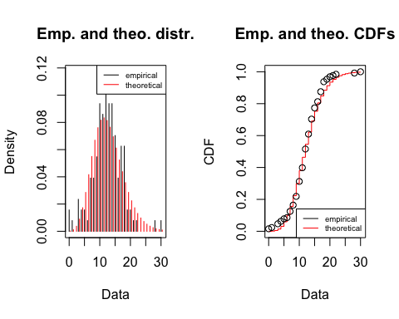

qqplot(x=qnbinom(samp.pct5,size.nbinom5,prob.nbinom5), y=sort(rich_36_df$Richness_change_pos), xlab = 'Theoretical quantiles', ylab = 'Empirical quantiles', main='Q-Q plot Negative Binomial')  
abline(0,1,col="red")

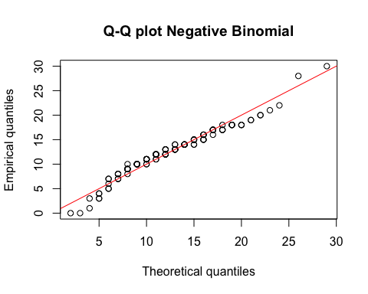

#looks ok, but is it good enough?  
  
#fit the model  
rich_36_nb_h2a=glm.nb(Richness_change_pos~Quadrat_fenced+Treatment+Quadrat_gap, rich_36_df)  
summary(rich_36_nb_h2a)

##   
## Call:  
## glm.nb(formula = Richness_change_pos ~ Quadrat_fenced + Treatment +   
## Quadrat_gap, data = rich_36_df, init.theta = 14.0221531,   
## link = log)  
##   
## Deviance Residuals:   
## Min 1Q Median 3Q Max   
## -4.1425 -0.5817 0.0349 0.5560 2.7227   
##   
## Coefficients:  
## Estimate Std. Error z value Pr(>|z|)   
## (Intercept) 2.6129801 0.0682449 38.288 <2e-16 ***  
## Quadrat_fencedTrue -0.0004747 0.0701246 -0.007 0.9946   
## TreatmentRadial 0.0273271 0.0701339 0.390 0.6968   
## Quadrat_gapTrue -0.1688754 0.0738034 -2.288 0.0221 *   
## ---  
## Signif. codes: 0 '***' 0.001 '**' 0.01 '*' 0.05 '.' 0.1 ' ' 1  
##   
## (Dispersion parameter for Negative Binomial(14.0222) family taken to be 1)  
##   
## Null deviance: 155.00 on 127 degrees of freedom  
## Residual deviance: 149.59 on 124 degrees of freedom  
## AIC: 782.09  
##   
## Number of Fisher Scoring iterations: 1  
##   
##   
## Theta: 14.02   
## Std. Err.: 4.07   
##   
## 2 x log-likelihood: -772.089

#goodness of fit  
qchisq(0.95,124)

## [1] 150.9894

#Adequate  
  
rich_36_nb_h2b=glm.nb(Richness_change_pos~Quadrat_fenced+Quadrat_gap, rich_36_df)  
summary(rich_36_nb_h2b) #choose this

##   
## Call:  
## glm.nb(formula = Richness_change_pos ~ Quadrat_fenced + Quadrat_gap,   
## data = rich_36_df, init.theta = 13.98536367, link = log)  
##   
## Deviance Residuals:   
## Min 1Q Median 3Q Max   
## -4.1223 -0.5759 0.0450 0.5819 2.7600   
##   
## Coefficients:  
## Estimate Std. Error z value Pr(>|z|)   
## (Intercept) 2.623657 0.062476 41.995 <2e-16 ***  
## Quadrat_fencedTrue -0.001611 0.070139 -0.023 0.9817   
## Quadrat_gapTrue -0.163256 0.072581 -2.249 0.0245 *   
## ---  
## Signif. codes: 0 '***' 0.001 '**' 0.01 '*' 0.05 '.' 0.1 ' ' 1  
##   
## (Dispersion parameter for Negative Binomial(13.9854) family taken to be 1)  
##   
## Null deviance: 154.84 on 127 degrees of freedom  
## Residual deviance: 149.59 on 125 degrees of freedom  
## AIC: 780.24  
##   
## Number of Fisher Scoring iterations: 1  
##   
##   
## Theta: 13.99   
## Std. Err.: 4.05   
##   
## 2 x log-likelihood: -772.241

#goodness of fit  
qchisq(0.95,125)

## [1] 152.0939

#Adequate  
  
rich_36_nb_h2c=glm.nb(Richness_change_pos~Quadrat_gap, rich_36_df)  
summary(rich_36_nb_h2c)

##   
## Call:  
## glm.nb(formula = Richness_change_pos ~ Quadrat_gap, data = rich_36_df,   
## init.theta = 13.98498585, link = log)  
##   
## Deviance Residuals:   
## Min 1Q Median 3Q Max   
## -4.1234 -0.5752 0.0423 0.5836 2.7577   
##   
## Coefficients:  
## Estimate Std. Error z value Pr(>|z|)   
## (Intercept) 2.62306 0.05659 46.356 <2e-16 ***  
## Quadrat_gapTrue -0.16357 0.07137 -2.292 0.0219 *   
## ---  
## Signif. codes: 0 '***' 0.001 '**' 0.01 '*' 0.05 '.' 0.1 ' ' 1  
##   
## (Dispersion parameter for Negative Binomial(13.985) family taken to be 1)  
##   
## Null deviance: 154.84 on 127 degrees of freedom  
## Residual deviance: 149.59 on 126 degrees of freedom  
## AIC: 778.24  
##   
## Number of Fisher Scoring iterations: 1  
##   
##   
## Theta: 13.98   
## Std. Err.: 4.05   
##   
## 2 x log-likelihood: -772.241

#goodness of fit  
qchisq(0.95,126)

## [1] 153.1979

#Adequate  
anova(rich_36_nb_h2c,rich_36_nb_h2b)

## Likelihood ratio tests of Negative Binomial Models  
##   
## Response: Richness_change_pos  
## Model theta Resid. df 2 x log-lik. Test df  
## 1 Quadrat_gap 13.98499 126 -772.2411   
## 2 Quadrat_fenced + Quadrat_gap 13.98536 125 -772.2406 1 vs 2 1  
## LR stat. Pr(Chi)  
## 1   
## 2 0.0005259388 0.9817034

#Quadrat_fenced is not significant  
glm.diag.plots((rich_36_nb_h2b))

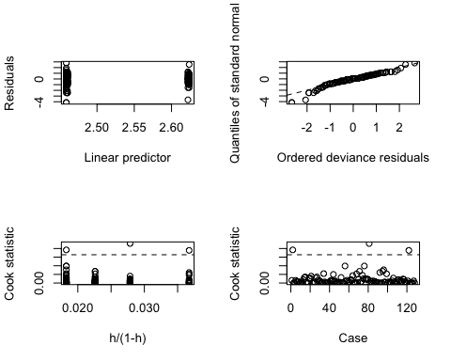

#heavy left tail

# try incorporate random effects

rich_36_nbmm_h2b=glmer.nb(Richness_change_pos~Quadrat_fenced+Quadrat_gap+(1|Plot_number/Quadrat_number), data=rich_36_df)

## Warning in theta.ml(Y, mu, weights = object@resp$weights, limit = limit, :  
## iteration limit reached

summary(rich_36_nbmm_h2b)

## Generalized linear mixed model fit by maximum likelihood (Laplace  
## Approximation) [glmerMod]  
## Family: Negative Binomial(1994.486) ( log )  
## Formula:   
## Richness_change_pos ~ Quadrat_fenced + Quadrat_gap + (1 | Plot_number/Quadrat_number)  
## Data: rich_36_df  
##   
## AIC BIC logLik deviance df.resid   
## 784.3 801.4 -386.1 772.3 122   
##   
## Scaled residuals:   
## Min 1Q Median 3Q Max   
## -2.79357 -0.38932 -0.00372 0.46833 1.91834   
##   
## Random effects:  
## Groups Name Variance Std.Dev.  
## Quadrat_number:Plot_number (Intercept) 0.056202 0.23707   
## Plot_number (Intercept) 0.005879 0.07667   
## Number of obs: 128, groups: Quadrat_number:Plot_number, 128; Plot_number, 4  
##   
## Fixed effects:  
## Estimate Std. Error z value Pr(>|z|)   
## (Intercept) 2.586672 0.071816 36.018 <2e-16 ***  
## Quadrat_fencedTrue -0.009728 0.067159 -0.145 0.8848   
## Quadrat_gapTrue -0.147780 0.071844 -2.057 0.0397 *   
## ---  
## Signif. codes: 0 '***' 0.001 '**' 0.01 '*' 0.05 '.' 0.1 ' ' 1  
##   
## Correlation of Fixed Effects:  
## (Intr) Qdrt_fT  
## Qdrt_fncdTr -0.339   
## Quadrt_gpTr -0.538 -0.192

#test the significance of random effect  
LRT = 2 * (-logLik(rich_36_nbmm_h2b)) - 2 * (-logLik(rich_36_nb_h2b))  
LRT

## 'log Lik.' 0.03596546 (df=6)

pchisq(as.numeric(LRT), df=2, lower.tail=F)

## [1] 0.982178

#not significant

### Y0 to 6 (Choose Negative Binomial GLM*)

# Linear model  
rich_06_lm_h2a=lm(Richness_change~Quadrat_fenced+Treatment+Quadrat_gap,data=rich_06_df)  
summary(rich_06_lm_h2a)

##   
## Call:  
## lm(formula = Richness_change ~ Quadrat_fenced + Treatment + Quadrat_gap,   
## data = rich_06_df)  
##   
## Residuals:  
## Min 1Q Median 3Q Max   
## -12.3486 -3.0673 -0.3486 3.1104 10.3687   
##   
## Coefficients:  
## Estimate Std. Error t value Pr(>|t|)   
## (Intercept) -0.8406 0.7665 -1.097 0.27491   
## Quadrat_fencedTrue -0.5281 0.7734 -0.683 0.49601   
## TreatmentRadial -2.2468 0.7734 -2.905 0.00435 **  
## Quadrat_gapTrue -0.5640 0.8233 -0.685 0.49463   
## ---  
## Signif. codes: 0 '***' 0.001 '**' 0.01 '*' 0.05 '.' 0.1 ' ' 1  
##   
## Residual standard error: 4.301 on 124 degrees of freedom  
## Multiple R-squared: 0.07907, Adjusted R-squared: 0.05679   
## F-statistic: 3.549 on 3 and 124 DF, p-value: 0.01652

plot(rich_06_lm_h2a)

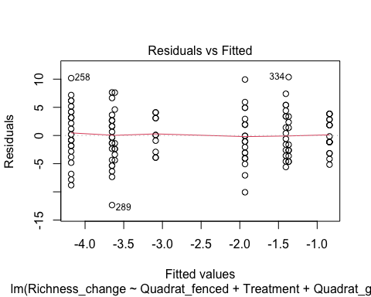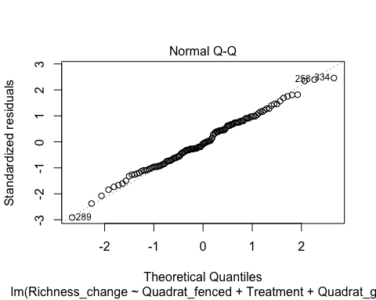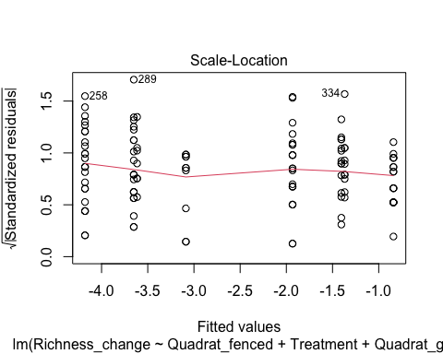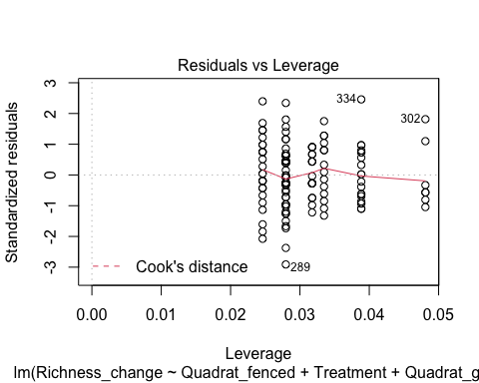

rich_06_lm_h2b=lm(Richness_change~Quadrat_fenced+Treatment,rich_06_df)  
summary(rich_06_lm_h2b)

##   
## Call:  
## lm(formula = Richness_change ~ Quadrat_fenced + Treatment, data = rich_06_df)  
##   
## Residuals:  
## Min 1Q Median 3Q Max   
## -12.5469 -2.8984 -0.5469 3.1094 10.7344   
##   
## Coefficients:  
## Estimate Std. Error t value Pr(>|t|)   
## (Intercept) -1.1094 0.6571 -1.688 0.09383 .   
## Quadrat_fencedTrue -0.6250 0.7587 -0.824 0.41164   
## TreatmentRadial -2.3438 0.7587 -3.089 0.00247 **  
## ---  
## Signif. codes: 0 '***' 0.001 '**' 0.01 '*' 0.05 '.' 0.1 ' ' 1  
##   
## Residual standard error: 4.292 on 125 degrees of freedom  
## Multiple R-squared: 0.07559, Adjusted R-squared: 0.0608   
## F-statistic: 5.111 on 2 and 125 DF, p-value: 0.007355

plot(rich_06_lm_h2b)

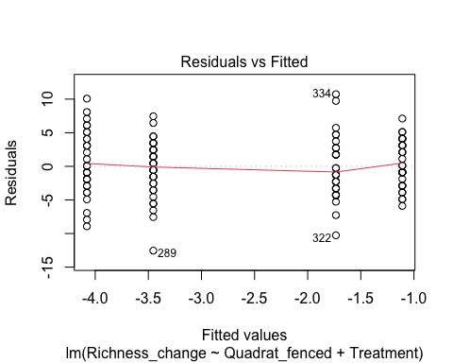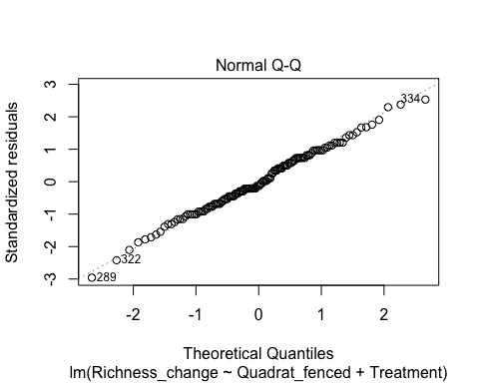

## hat values (leverages) are all = 0.0234375  
## and there are no factor predictors; no plot no. 5

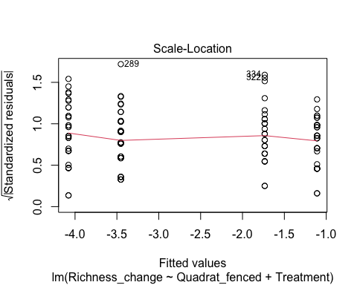

anova(rich_06_lm_h2b,rich_06_lm_h2a)

## Analysis of Variance Table  
##   
## Model 1: Richness_change ~ Quadrat_fenced + Treatment  
## Model 2: Richness_change ~ Quadrat_fenced + Treatment + Quadrat_gap  
## Res.Df RSS Df Sum of Sq F Pr(>F)  
## 1 125 2302.6   
## 2 124 2293.9 1 8.6801 0.4692 0.4946

rich_06_lm_h2c=lm(Richness_change~Treatment,rich_06_df)  
summary(rich_06_lm_h2c)

##   
## Call:  
## lm(formula = Richness_change ~ Treatment, data = rich_06_df)  
##   
## Residuals:  
## Min 1Q Median 3Q Max   
## -12.2344 -2.7422 -0.4062 3.4219 10.4219   
##   
## Coefficients:  
## Estimate Std. Error t value Pr(>|t|)   
## (Intercept) -1.4219 0.5358 -2.654 0.00899 **  
## TreatmentRadial -2.3438 0.7577 -3.093 0.00244 **  
## ---  
## Signif. codes: 0 '***' 0.001 '**' 0.01 '*' 0.05 '.' 0.1 ' ' 1  
##   
## Residual standard error: 4.286 on 126 degrees of freedom  
## Multiple R-squared: 0.07057, Adjusted R-squared: 0.06319   
## F-statistic: 9.567 on 1 and 126 DF, p-value: 0.00244

plot(rich_06_lm_h2c)

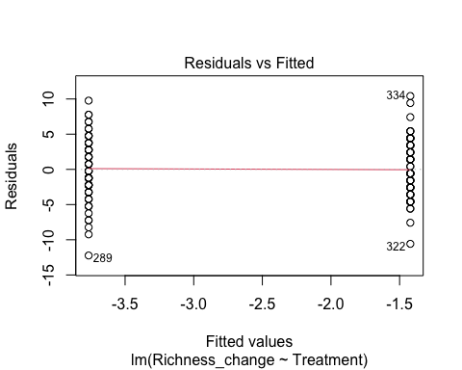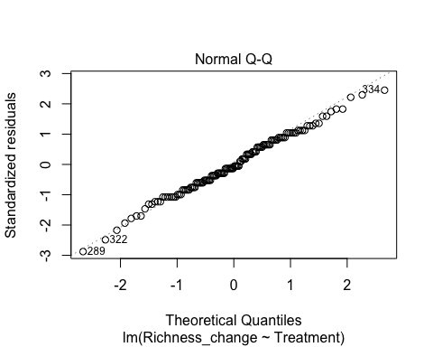

## hat values (leverages) are all = 0.015625  
## and there are no factor predictors; no plot no. 5

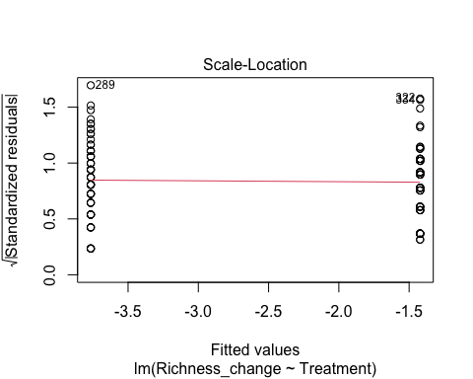

anova(rich_06_lm_h2c,rich_06_lm_h2b)

## Analysis of Variance Table  
##   
## Model 1: Richness_change ~ Treatment  
## Model 2: Richness_change ~ Quadrat_fenced + Treatment  
## Res.Df RSS Df Sum of Sq F Pr(>F)  
## 1 126 2315.1   
## 2 125 2302.6 1 12.5 0.6786 0.4116

#Quadrat_fenced is not significant

#Poisson GLM  
#manipulate data by adding a constant to every y, so that they are all non-negative  
q=min(rich_06_df$Richness_change)  
rich_06_df$Richness_change_pos=rich_06_df$Richness_change + abs(q)  
  
#visualisation and test if the data is poisson  
hist(rich_06_df$Richness_change_pos)

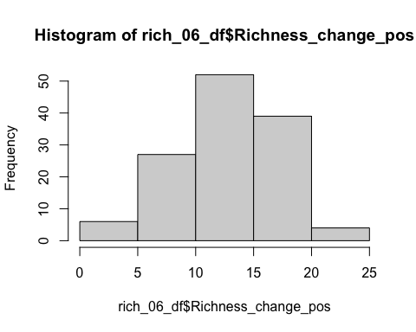

poisson.model6=fitdist(rich_06_df$Richness_change_pos,"pois",method=c("mle"))  
poisson.model6

## Fitting of the distribution ' pois ' by maximum likelihood   
## Parameters:  
## estimate Std. Error  
## lambda 13.40625 0.3236299

poisson.lambda6=13.40625   
  
plot(poisson.model6)

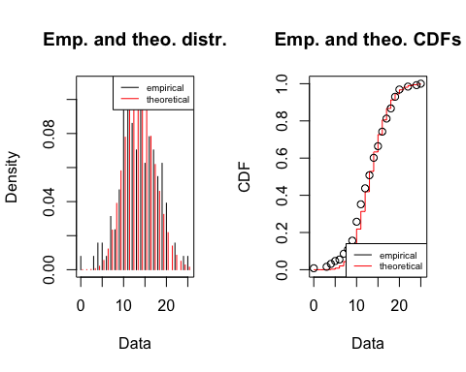

n6=length(rich_06_df$Richness_change_pos)  
samp.pct6 <- (1:n6-0.5)/n6  
qqplot(x=qpois(samp.pct6,poisson.lambda6), y=sort(rich_06_df$Richness_change_pos), xlab = 'Theoretical quantiles', ylab = 'Empirical quantiles', main='Q-Q plot Poisson')  
abline(0,1,col="red")

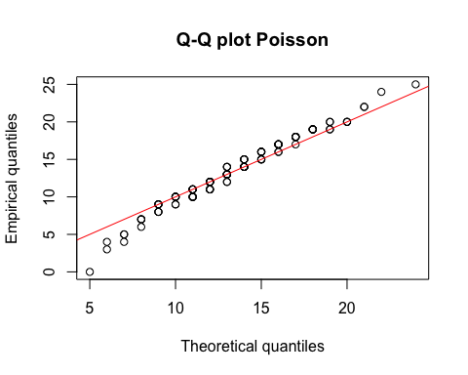

#looking ok  
  
#fit the model  
rich_06_pois_h2a=glm(Richness_change_pos~Quadrat_fenced+Treatment+Quadrat_gap, rich_06_df, family = poisson)  
summary(rich_06_pois_h2a)

##   
## Call:  
## glm(formula = Richness_change_pos ~ Quadrat_fenced + Treatment +   
## Quadrat_gap, family = poisson, data = rich_06_df)  
##   
## Deviance Residuals:   
## Min 1Q Median 3Q Max   
## -4.9672 -0.8449 -0.0963 0.8468 2.6275   
##   
## Coefficients:  
## Estimate Std. Error z value Pr(>|z|)   
## (Intercept) 2.72176 0.04689 58.045 < 2e-16 ***  
## Quadrat_fencedTrue -0.03925 0.04919 -0.798 0.424823   
## TreatmentRadial -0.16810 0.04931 -3.409 0.000651 ***  
## Quadrat_gapTrue -0.04109 0.05178 -0.794 0.427407   
## ---  
## Signif. codes: 0 '***' 0.001 '**' 0.01 '*' 0.05 '.' 0.1 ' ' 1  
##   
## (Dispersion parameter for poisson family taken to be 1)  
##   
## Null deviance: 206.94 on 127 degrees of freedom  
## Residual deviance: 192.25 on 124 degrees of freedom  
## AIC: 758.58  
##   
## Number of Fisher Scoring iterations: 4

#goodness of fit  
qchisq(0.95,124)

## [1] 150.9894

#not adequate  
  
  
rich_06_pois_h2b=glm(Richness_change_pos~Quadrat_fenced+Treatment, rich_06_df, family = poisson)  
summary(rich_06_pois_h2b)

##   
## Call:  
## glm(formula = Richness_change_pos ~ Quadrat_fenced + Treatment,   
## family = poisson, data = rich_06_df)  
##   
## Deviance Residuals:   
## Min 1Q Median 3Q Max   
## -5.0039 -0.8099 -0.1479 0.7916 2.5990   
##   
## Coefficients:  
## Estimate Std. Error z value Pr(>|z|)   
## (Intercept) 2.70256 0.04035 66.980 < 2e-16 ***  
## Quadrat_fencedTrue -0.04663 0.04829 -0.966 0.334283   
## TreatmentRadial -0.17527 0.04847 -3.616 0.000299 ***  
## ---  
## Signif. codes: 0 '***' 0.001 '**' 0.01 '*' 0.05 '.' 0.1 ' ' 1  
##   
## (Dispersion parameter for poisson family taken to be 1)  
##   
## Null deviance: 206.94 on 127 degrees of freedom  
## Residual deviance: 192.88 on 125 degrees of freedom  
## AIC: 757.21  
##   
## Number of Fisher Scoring iterations: 4

#goodness of fit  
qchisq(0.95,125)

## [1] 152.0939

#not adequate  
P__disp(rich_36_pois_h2b)

## pearson.chi2 dispersion   
## 226.574822 1.812599

#high dispersion  
  
rich_06_pois_h2c=glm(Richness_change_pos~Treatment, rich_06_df, family = poisson)  
summary(rich_06_pois_h2c)

##   
## Call:  
## glm(formula = Richness_change_pos ~ Treatment, family = poisson,   
## data = rich_06_df)  
##   
## Deviance Residuals:   
## Min 1Q Median 3Q Max   
## -4.9466 -0.7653 -0.1098 0.8642 2.5075   
##   
## Coefficients:  
## Estimate Std. Error z value Pr(>|z|)   
## (Intercept) 2.67952 0.03274 81.846 < 2e-16 ***  
## TreatmentRadial -0.17527 0.04847 -3.616 0.000299 ***  
## ---  
## Signif. codes: 0 '***' 0.001 '**' 0.01 '*' 0.05 '.' 0.1 ' ' 1  
##   
## (Dispersion parameter for poisson family taken to be 1)  
##   
## Null deviance: 206.94 on 127 degrees of freedom  
## Residual deviance: 193.81 on 126 degrees of freedom  
## AIC: 756.14  
##   
## Number of Fisher Scoring iterations: 4

#goodness of fit  
qchisq(0.95,126)

## [1] 153.1979

#not adequate  
  
anova(rich_06_pois_h2c,rich_06_pois_h2b)

## Analysis of Deviance Table  
##   
## Model 1: Richness_change_pos ~ Treatment  
## Model 2: Richness_change_pos ~ Quadrat_fenced + Treatment  
## Resid. Df Resid. Dev Df Deviance  
## 1 126 193.81   
## 2 125 192.88 1 0.93249

qchisq(0.95,1)

## [1] 3.841459

# None of the models are adequate  
# Quadrat_fenced is not significant

#Negative Binomial GLM  
#Test if the data is Negative Binomial   
nbinom.model6=fitdist(rich_06_df$Richness_change_pos,"nbinom",method=c("mle"))  
nbinom.model6

## Fitting of the distribution ' nbinom ' by maximum likelihood   
## Parameters:  
## estimate Std. Error  
## size 25.75613 10.0229050  
## mu 13.40744 0.3991118

size.nbinom6=25.75613 #first parameter   
mu.nbinom6=13.40744   
prob.nbinom6=size.nbinom6/(size.nbinom6+mu.nbinom6)   
prob.nbinom6

## [1] 0.6576553

plot(nbinom.model6)

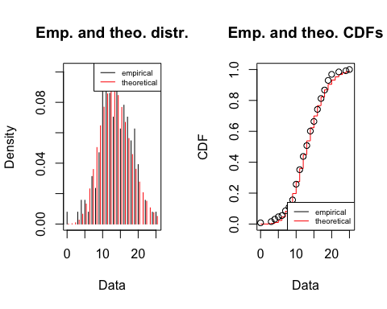

qqplot(x=qnbinom(samp.pct6,size.nbinom6,prob.nbinom6), y=sort(rich_06_df$Richness_change_pos), xlab = 'Theoretical quantiles', ylab = 'Empirical quantiles', main='Q-Q plot Negative Binomial')  
abline(0,1,col="red")

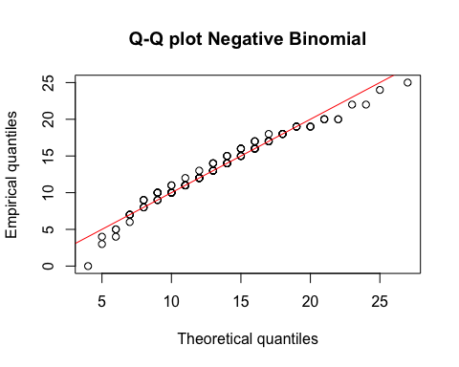

#looks better than Poisson  
  
#fit the model  
rich_06_nb_h2a=glm.nb(Richness_change_pos~Quadrat_fenced+Treatment+Quadrat_gap, rich_06_df)  
summary(rich_06_nb_h2a)

##   
## Call:  
## glm.nb(formula = Richness_change_pos ~ Quadrat_fenced + Treatment +   
## Quadrat_gap, data = rich_06_df, init.theta = 34.5274613,   
## link = log)  
##   
## Deviance Residuals:   
## Min 1Q Median 3Q Max   
## -4.5915 -0.7182 -0.0803 0.7147 2.1958   
##   
## Coefficients:  
## Estimate Std. Error z value Pr(>|z|)   
## (Intercept) 2.72113 0.05588 48.694 < 2e-16 ***  
## Quadrat_fencedTrue -0.03766 0.05797 -0.650 0.51598   
## TreatmentRadial -0.16775 0.05803 -2.891 0.00384 **   
## Quadrat_gapTrue -0.04161 0.06121 -0.680 0.49669   
## ---  
## Signif. codes: 0 '***' 0.001 '**' 0.01 '*' 0.05 '.' 0.1 ' ' 1  
##   
## (Dispersion parameter for Negative Binomial(34.5275) family taken to be 1)  
##   
## Null deviance: 154.54 on 127 degrees of freedom  
## Residual deviance: 143.99 on 124 degrees of freedom  
## AIC: 753.92  
##   
## Number of Fisher Scoring iterations: 1  
##   
##   
## Theta: 34.5   
## Std. Err.: 16.6   
##   
## 2 x log-likelihood: -743.92

#goodness of fit  
qchisq(0.95,124)

## [1] 150.9894

#Adequate  
  
rich_06_nb_h2b=glm.nb(Richness_change_pos~Quadrat_fenced+Treatment, rich_06_df)  
summary(rich_06_nb_h2b) #choose this

##   
## Call:  
## glm.nb(formula = Richness_change_pos ~ Quadrat_fenced + Treatment,   
## data = rich_06_df, init.theta = 34.04807483, link = log)  
##   
## Deviance Residuals:   
## Min 1Q Median 3Q Max   
## -4.6166 -0.6827 -0.1250 0.6607 2.1653   
##   
## Coefficients:  
## Estimate Std. Error z value Pr(>|z|)   
## (Intercept) 2.70160 0.04816 56.096 < 2e-16 ***  
## Quadrat_fencedTrue -0.04506 0.05705 -0.790 0.42965   
## TreatmentRadial -0.17487 0.05716 -3.059 0.00222 **   
## ---  
## Signif. codes: 0 '***' 0.001 '**' 0.01 '*' 0.05 '.' 0.1 ' ' 1  
##   
## (Dispersion parameter for Negative Binomial(34.0481) family taken to be 1)  
##   
## Null deviance: 154.00 on 127 degrees of freedom  
## Residual deviance: 143.95 on 125 degrees of freedom  
## AIC: 752.38  
##   
## Number of Fisher Scoring iterations: 1  
##   
##   
## Theta: 34.0   
## Std. Err.: 16.2   
##   
## 2 x log-likelihood: -744.38

#goodness of fit  
qchisq(0.95,125)

## [1] 152.0939

#Adequate  
  
rich_06_nb_h2c=glm.nb(Richness_change_pos~Treatment, rich_06_df)  
summary(rich_06_nb_h2c)

##   
## Call:  
## glm.nb(formula = Richness_change_pos ~ Treatment, data = rich_06_df,   
## init.theta = 33.27093686, link = log)  
##   
## Deviance Residuals:   
## Min 1Q Median 3Q Max   
## -4.5648 -0.6469 -0.0924 0.7126 2.0803   
##   
## Coefficients:  
## Estimate Std. Error z value Pr(>|z|)   
## (Intercept) 2.67952 0.03926 68.249 < 2e-16 ***  
## TreatmentRadial -0.17527 0.05734 -3.057 0.00224 **   
## ---  
## Signif. codes: 0 '***' 0.001 '**' 0.01 '*' 0.05 '.' 0.1 ' ' 1  
##   
## (Dispersion parameter for Negative Binomial(33.2709) family taken to be 1)  
##   
## Null deviance: 153.11 on 127 degrees of freedom  
## Residual deviance: 143.74 on 126 degrees of freedom  
## AIC: 751  
##   
## Number of Fisher Scoring iterations: 1  
##   
##   
## Theta: 33.3   
## Std. Err.: 15.5   
##   
## 2 x log-likelihood: -745.002

#goodness of fit  
qchisq(0.95,126)

## [1] 153.1979

#Adequate  
anova(rich_06_nb_h2c,rich_06_nb_h2b)

## Likelihood ratio tests of Negative Binomial Models  
##   
## Response: Richness_change_pos  
## Model theta Resid. df 2 x log-lik. Test df  
## 1 Treatment 33.27094 126 -745.0016   
## 2 Quadrat_fenced + Treatment 34.04807 125 -744.3802 1 vs 2 1  
## LR stat. Pr(Chi)  
## 1   
## 2 0.621377 0.430536

#Quadrat_fenced is not significant  
glm.diag.plots((rich_06_nb_h2b))

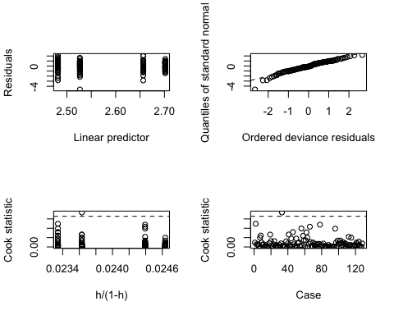

#heavy left tail

# try incorporate random effects

rich_06_nbmm_h2b=glmer.nb(Richness_change_pos~Quadrat_fenced+Treatment+(1|Plot_number/Quadrat_number), data=rich_06_df)

## Warning in theta.ml(Y, mu, weights = object@resp$weights, limit = limit, :  
## iteration limit reached

summary(rich_06_nbmm_h2b)

## Generalized linear mixed model fit by maximum likelihood (Laplace  
## Approximation) [glmerMod]  
## Family: Negative Binomial(1468.082) ( log )  
## Formula:   
## Richness_change_pos ~ Quadrat_fenced + Treatment + (1 | Plot_number/Quadrat_number)  
## Data: rich_06_df  
##   
## AIC BIC logLik deviance df.resid   
## 749.7 766.8 -368.8 737.7 122   
##   
## Scaled residuals:   
## Min 1Q Median 3Q Max   
## -3.06241 -0.64150 -0.07189 0.63711 2.28046   
##   
## Random effects:  
## Groups Name Variance Std.Dev.  
## Quadrat_number:Plot_number (Intercept) 0.01681 0.1297   
## Plot_number (Intercept) 0.01037 0.1018   
## Number of obs: 128, groups: Quadrat_number:Plot_number, 128; Plot_number, 4  
##   
## Fixed effects:  
## Estimate Std. Error z value Pr(>|z|)   
## (Intercept) 2.69139 0.08520 31.591 <2e-16 ***  
## Quadrat_fencedTrue -0.04583 0.05377 -0.852 0.394   
## TreatmentRadial -0.18096 0.11531 -1.569 0.117   
## ---  
## Signif. codes: 0 '***' 0.001 '**' 0.01 '*' 0.05 '.' 0.1 ' ' 1  
##   
## Correlation of Fixed Effects:  
## (Intr) Qdrt_T  
## Qdrt_fncdTr -0.308   
## TreatmntRdl -0.664 -0.002

#test the significance of random effect  
LRT = 2 * (-logLik(rich_06_nbmm_h2b)) - 2 * (-logLik(rich_06_nb_h2b))  
LRT

## 'log Lik.' -6.709231 (df=6)

pchisq(as.numeric(LRT), df=2, lower.tail=F)

## [1] 1

#not significant